Introduction to Data Science

Default of Credit Card Clients



Presented by:

**Group ID: 1**

Student Reg# Student Name

**L1F16BSCS0049 Mohsin Basti**

**L1F16BSCS0159 Abdullah Shafique**

**L1S16BSCS0021 Rehmat Ali Haider**

**Faculty of Information Technology**

**University of Central Punjab**

Table of Contents

1. Data Source

1.1 Data set Selection

1.2 Location Site of Data Source

1.3 Packages and Libraries Requirements

1.4 Data set Information

2. Data Cleansing

2.1 Dataset Exploration

2.3 Dataset Preprocessing

2.3.1 Loading/Extraction of the source Dataset

2.3.2 Extract/Filter Desired Attributes/Fields

2.3.3 Removing Duplicates Records

2.3.4 Structuring Date and Time Transformation

2.3.5 Replacing NA for Date-Time Observation/Records

2.3.6 Reformatting and Imputation of Date-Time Attributes

2.3.7 Imputation on Data-Time column

2.3.8 Creation Classifiers

2.3.9 Removing Others NA Records of Dataset

3. Identified Questions

4. Exploratory Data Analysis

5. Machine Learning Modeling

5.1 Statistics and Regression Modeling

5.1.1 Correlation

5.1.2 Regression

5.2 Classification Modeling

5.2.1 Decision Tree

5.2.2 Naïve Bayes

5.2.3 Comparison of Accuracy

6. Members Roles and Responsibilities

6.1 Group Rules

6.2 Task List

6.3 Matrix Score Weighted

7. Shiny Application Screen shots and published URL

1. **Data Source**
   1. **Data set Selection**

We have selected this dataset because it was related to our interest. Moreover, using this dataset we can make an application to predict the further defaults of credit cards of clients. Using this dataset, we will build such an application which will consider the variables of dataset as input and will predict the defaults of credit cards of further clients in future.

* 1. **Location Site of Data Source**

We have taken this dataset from the famous website which is UCI. This site provides bulk of datasets.

Following is the link from where we get this dataset.

<http://archive.ics.uci.edu/ml/datasets/default+of+credit+card+clients>

* 1. **Packages and Libraries Requirements**

The packages we have identified to use in this project till now are following:

**Packages:**

1: dplyr

2: ggplot2

3: plyr

4: tidyr

5: stringr

**Libraries:**

1: dplyr

2: plyr

3: ggplot2

4: tidyr

5: stringr

6: randomforest

7: naivebayes

8: neuralnet

9: caret

10: rpart

11: rpart.plot

12: class

13: caTools

14: naniar

15: e1070

We may use more libraries and packages after exploring more about the project. If we will use more libraries and packages then will be mention/update those in next document.

* 1. **Data set Information**

Following is the information regarding the data set we are using in our project:

This research aimed at the case of customers default payments in Taiwan and compares the predictive accuracy of probability of default among six data mining methods. From the perspective of risk management, the result of predictive accuracy of the estimated probability of default will be more valuable than the binary result of classification - credible or not credible clients. Because the real probability of default is unknown, this study presented the novel Sorting Smoothing Method to estimate the real probability of default. With the real probability of default as the response variable (Y), and the predictive probability of default as the independent variable (X), the simple linear regression result (Y = A + BX) shows that the forecasting model produced by artificial neural network has the highest coefficient of determination; its regression intercept (A) is close to zero, and regression coefficient (B) to one. Therefore, among the six data mining techniques, artificial neural network is the only one that can accurately estimate the real probability of default.

1. **Data Cleansing**
   1. **Dataset Exploration**

We have done Exploration of Our Dataset:

library(readxl)

myData <- read_excel("~/Desktop/default of credit card clients.xls")

View(myData)

**head(myData)**

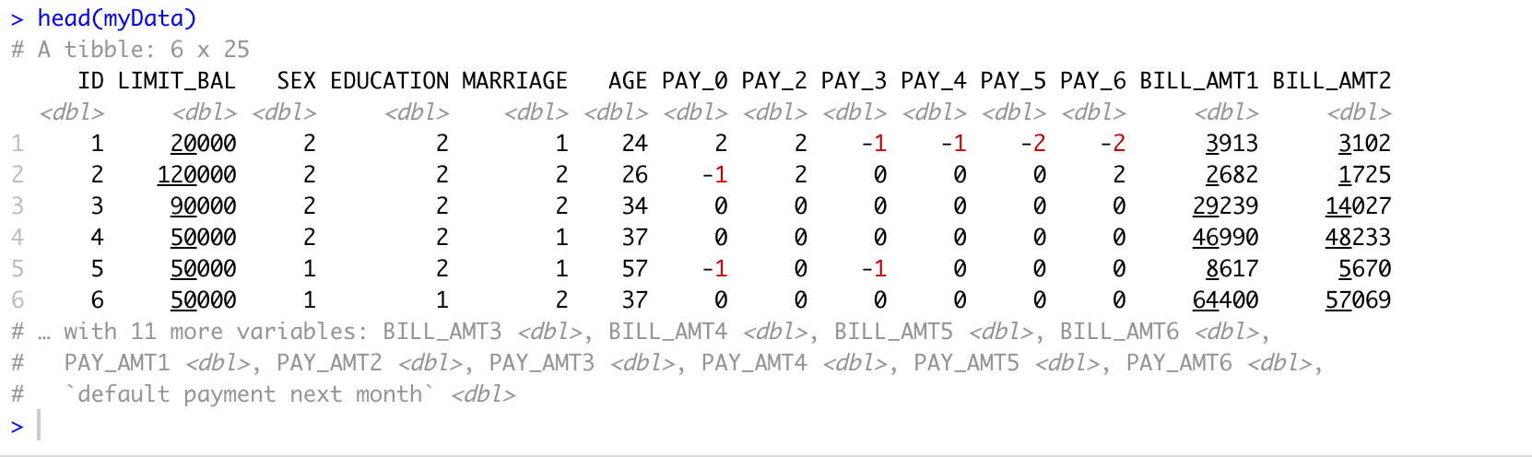

**tail(myData)**

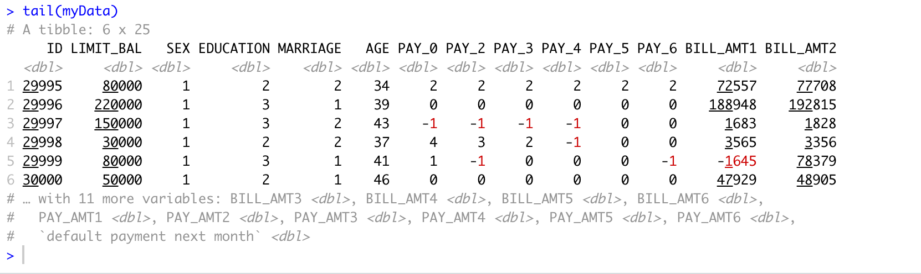

**class(myData)**



**dim(myData)**



**summary(myData)**

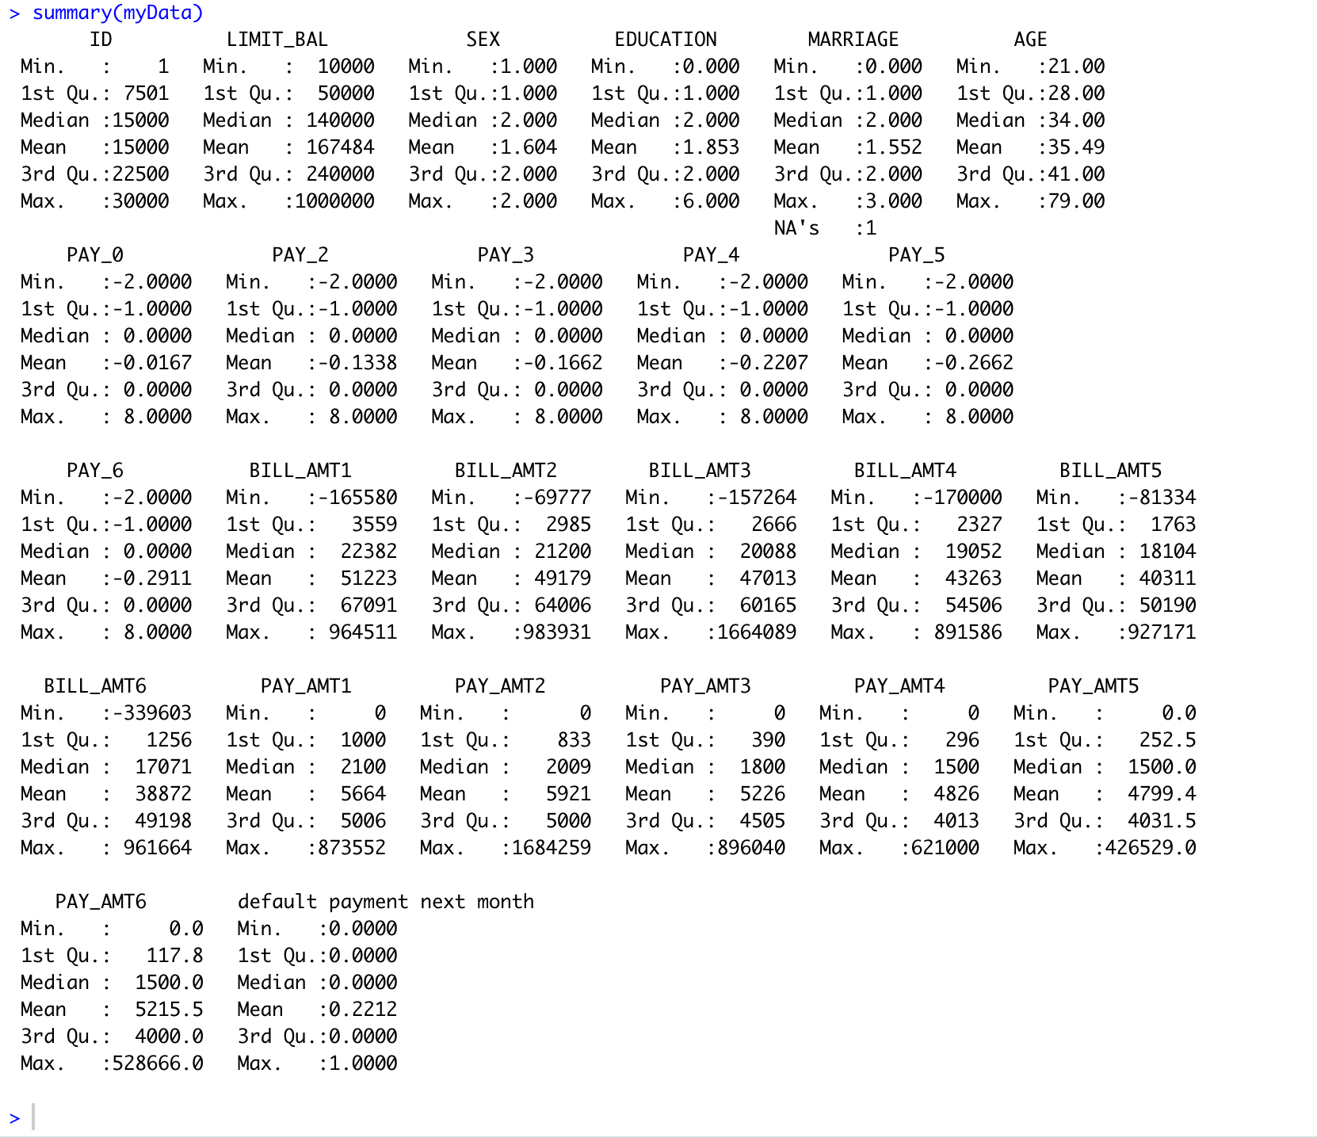

**names(myData)**

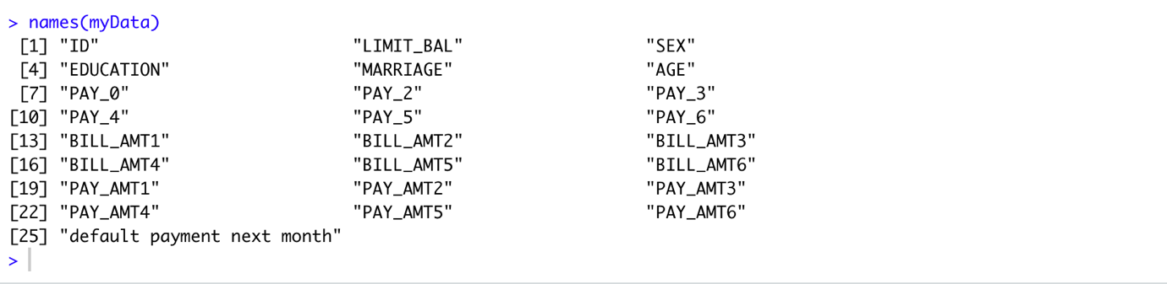

**str(myData)**

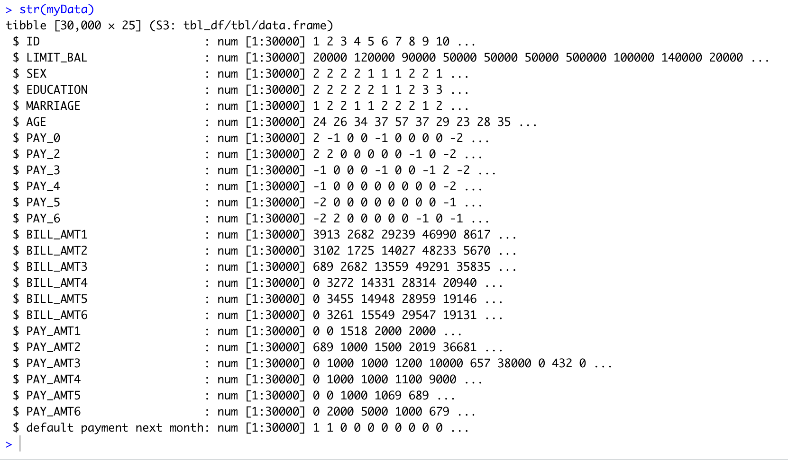

**glimpse(myData)**

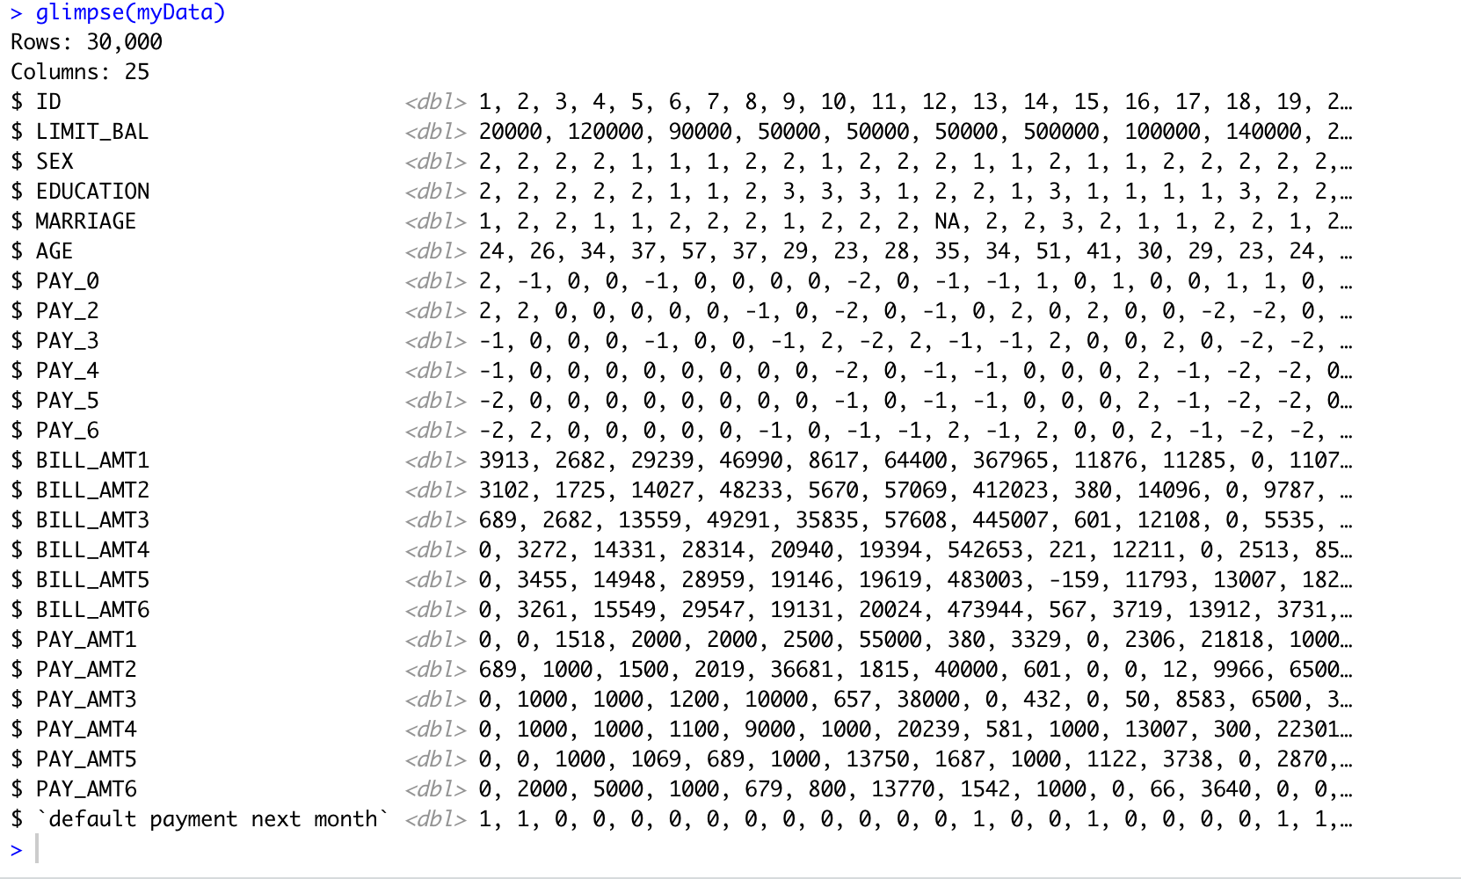

1. **Exploratory Data Analysis**

**Correlation Plot:**

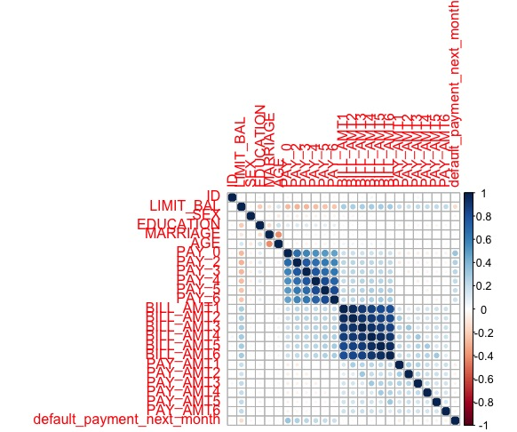

**Histogram Plot:**

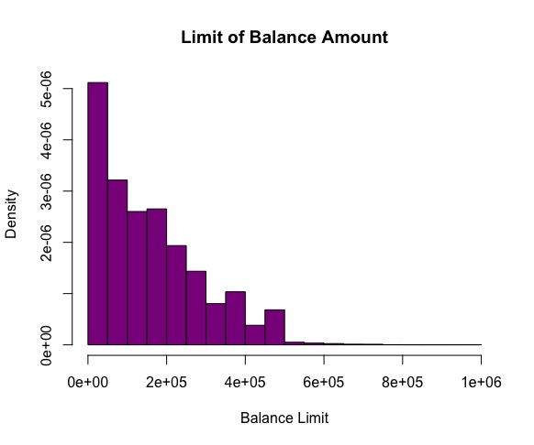

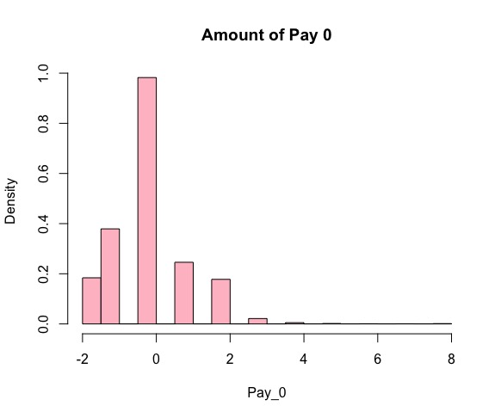

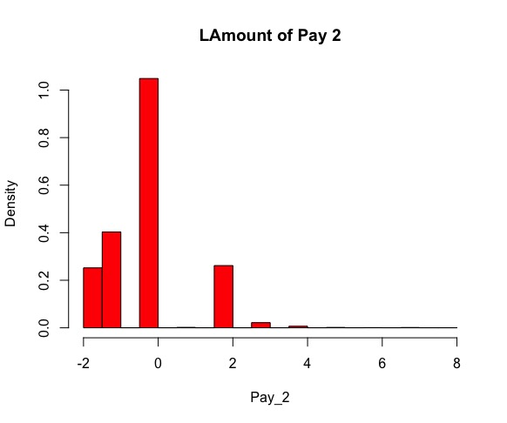

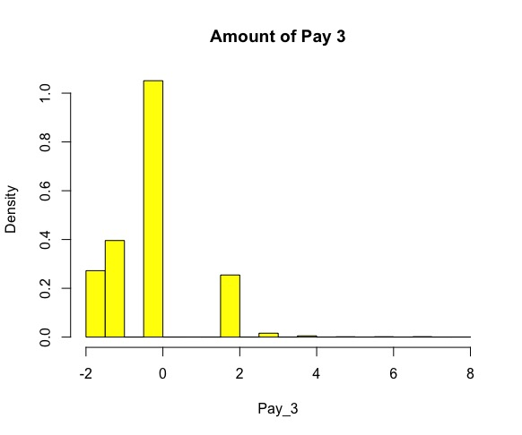

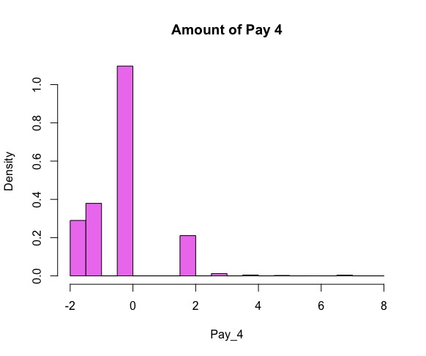

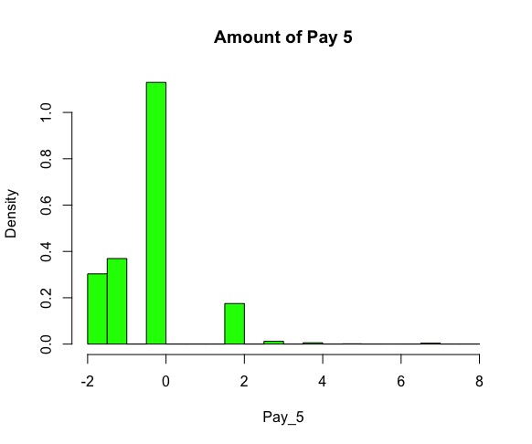

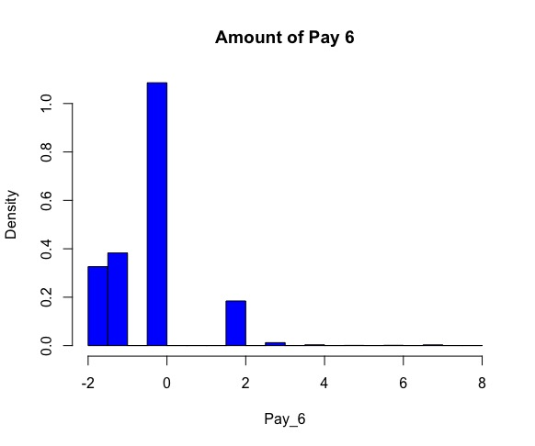

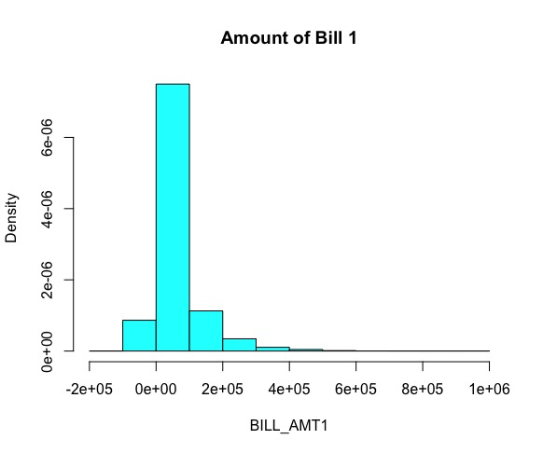

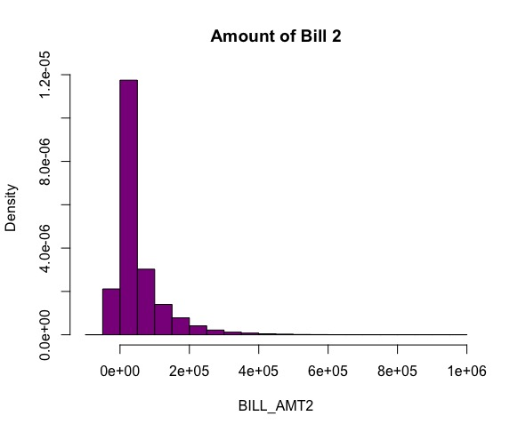

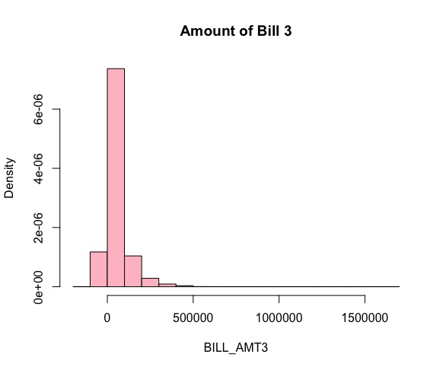

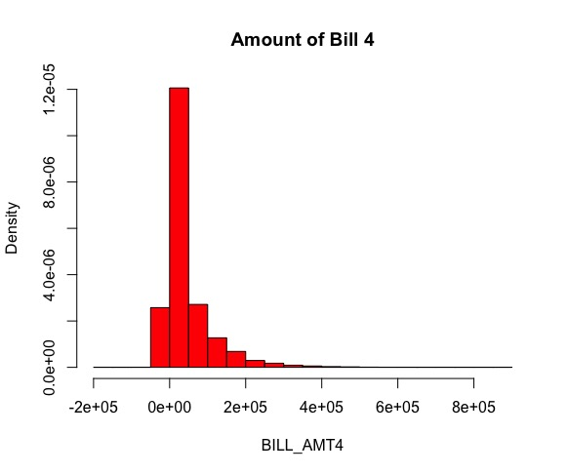

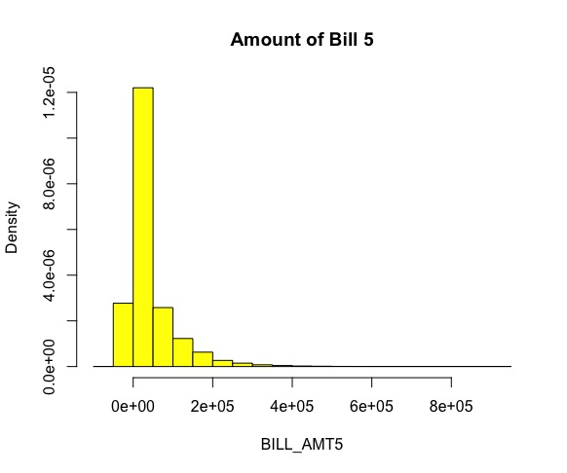

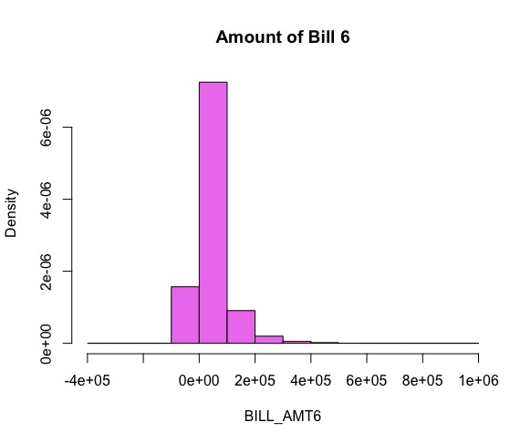

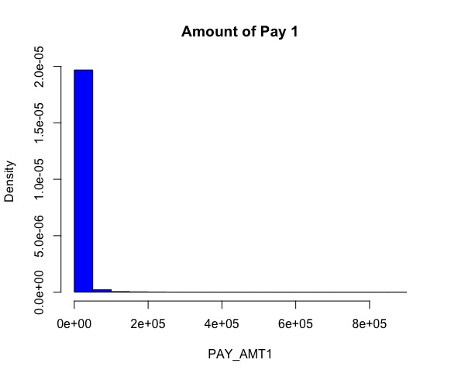

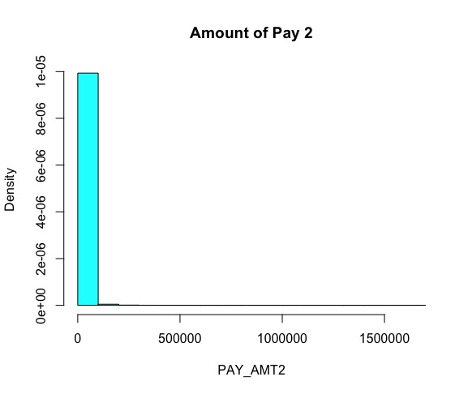

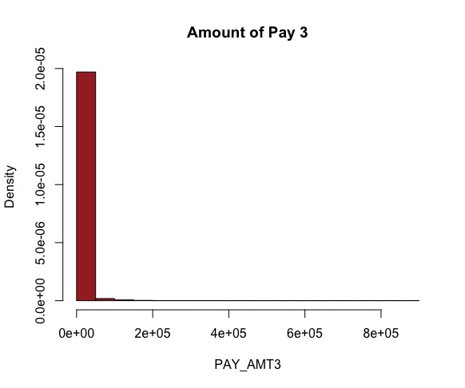

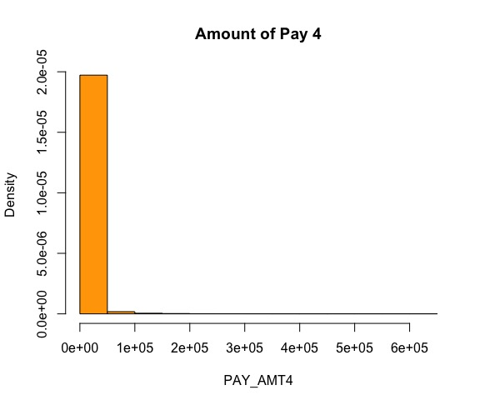

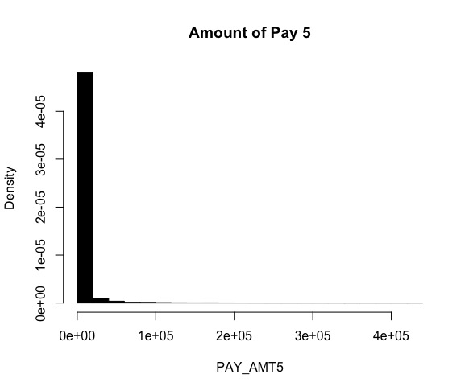

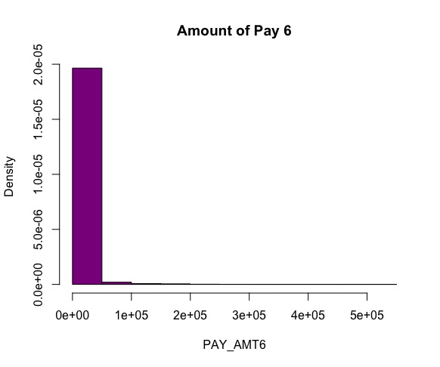

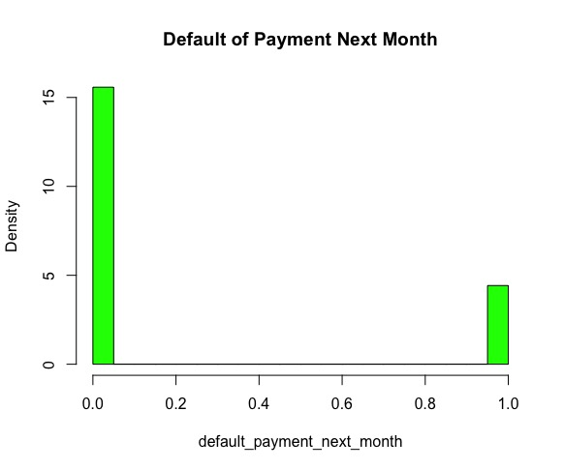

**Box Plot:**

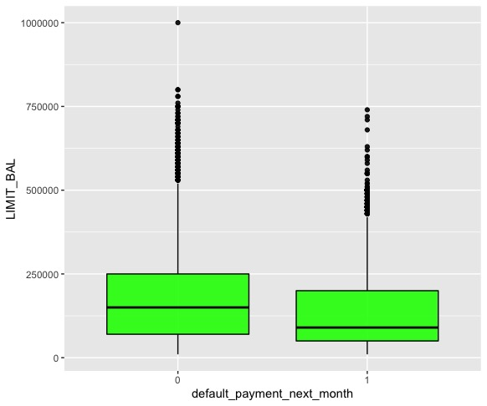

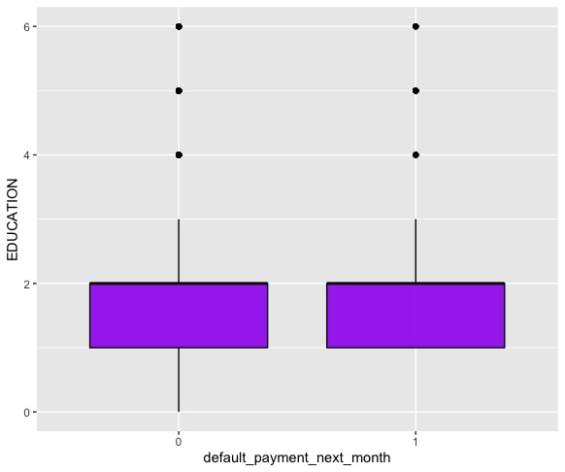

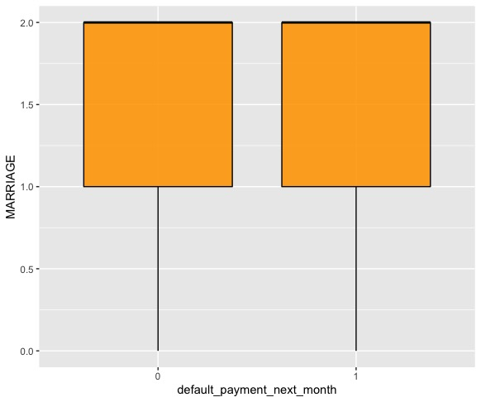

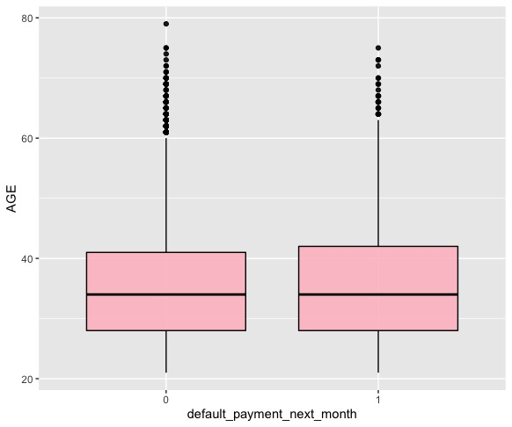

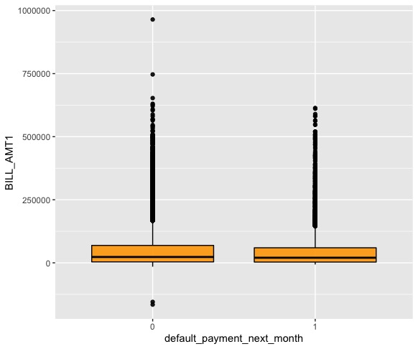

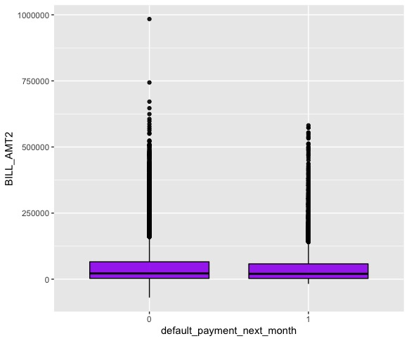

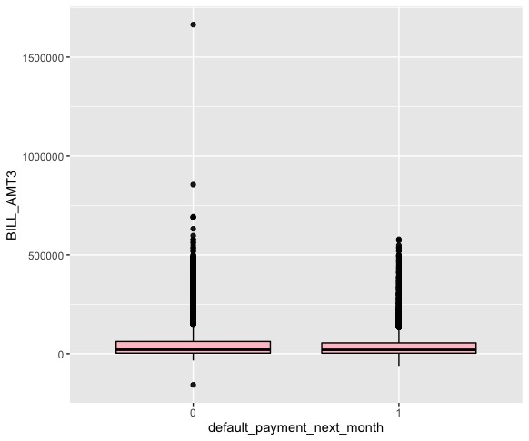

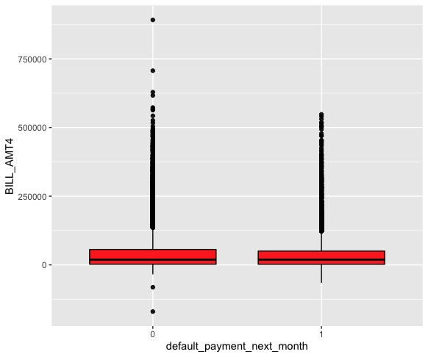

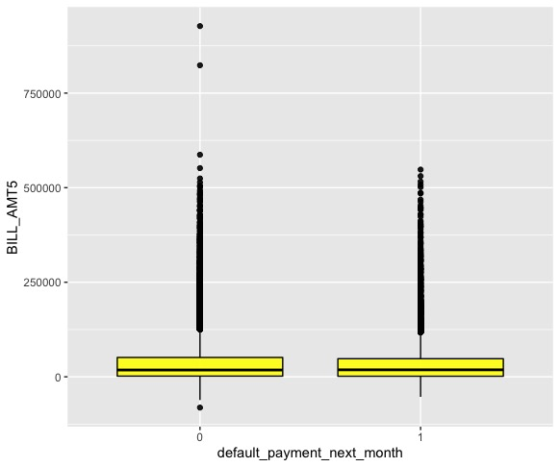

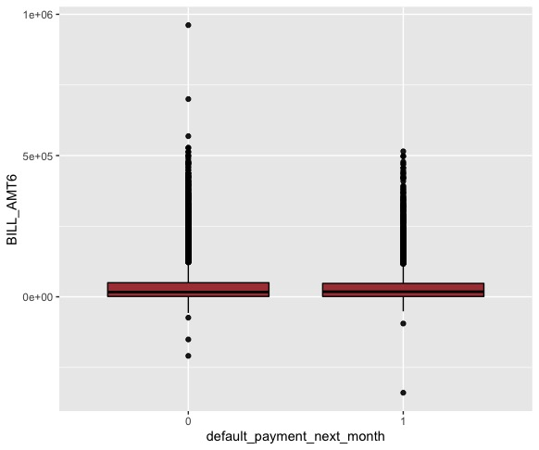

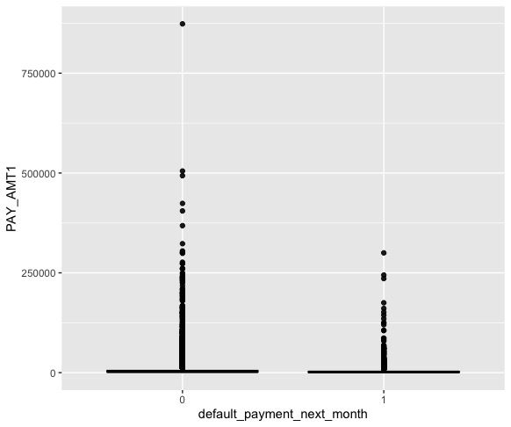

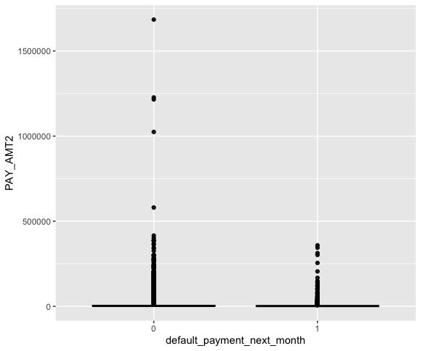

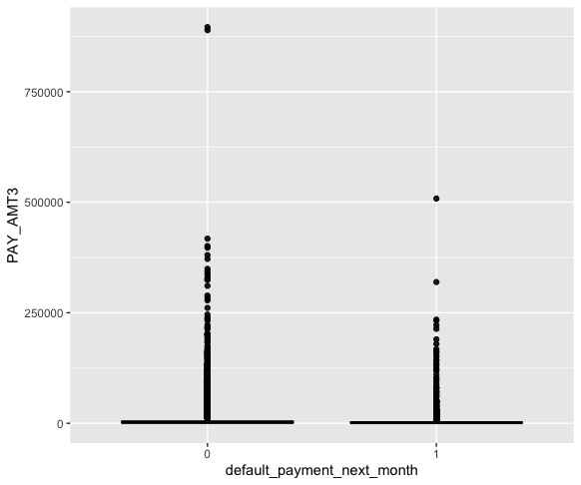

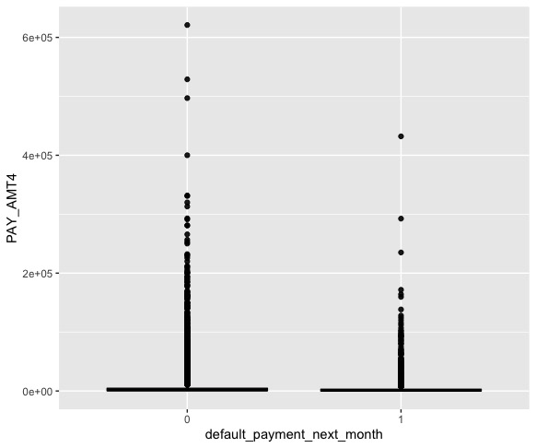

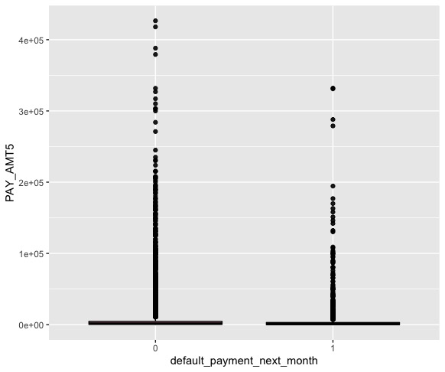

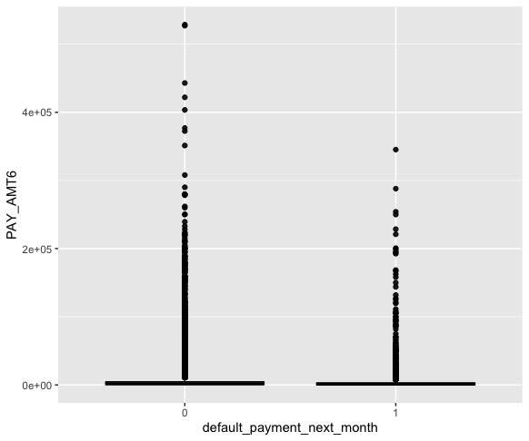

**Bar Plotting for Variables with Each other:**

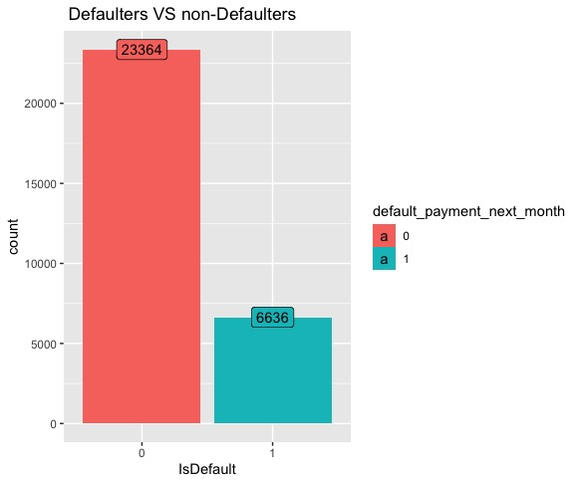

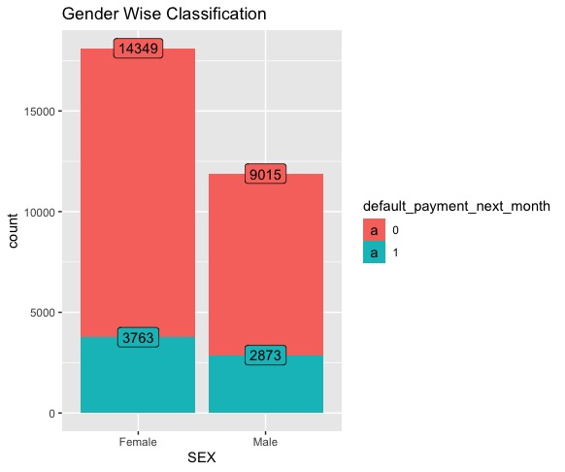

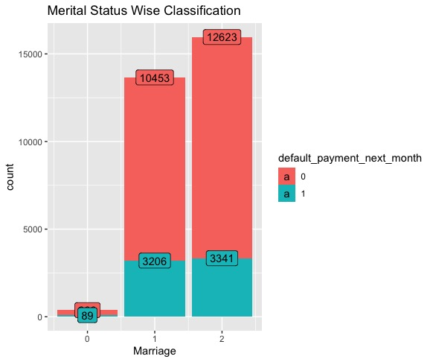

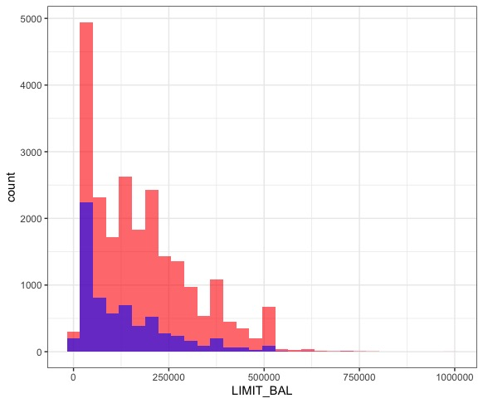

**Age VS Limit Balance:**

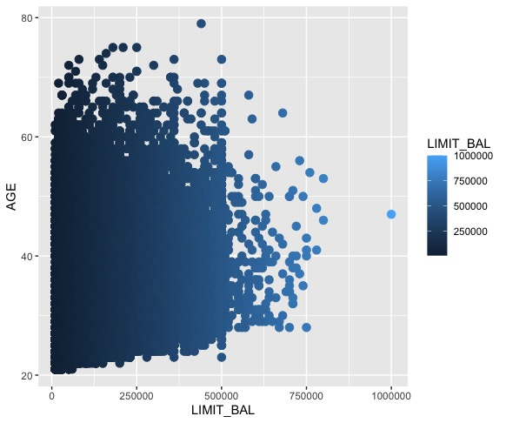

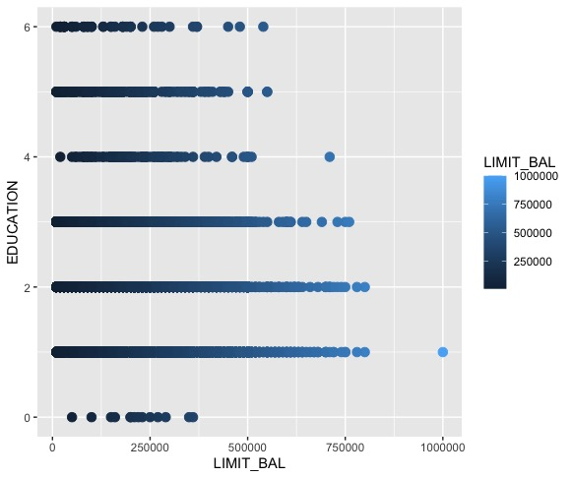

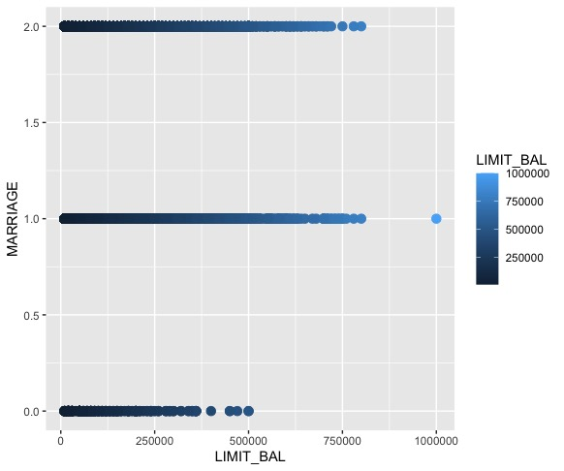

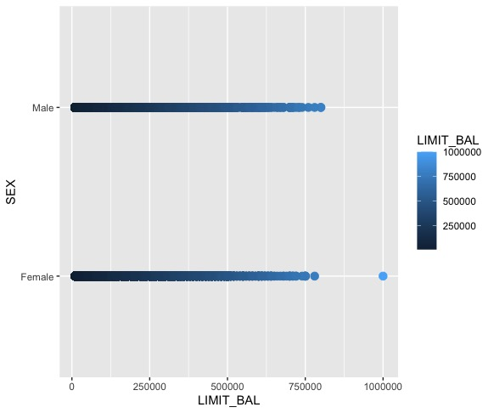

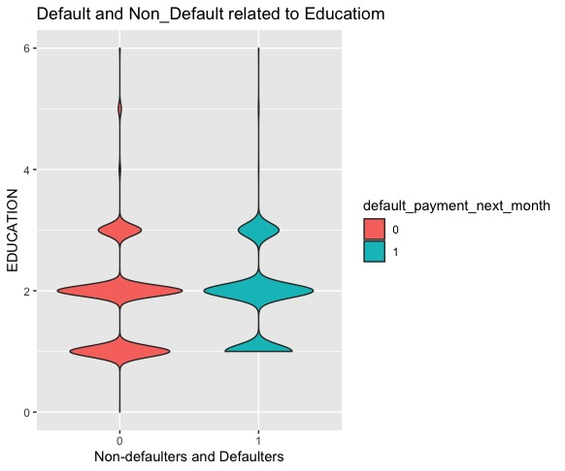

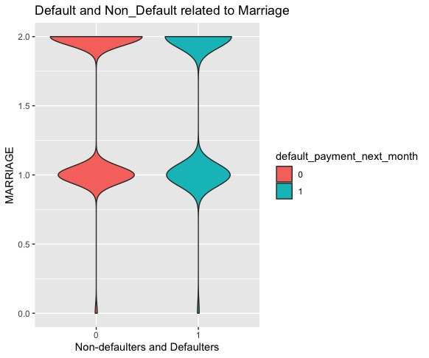

**Defaulters and Non-Defaulters WRT Age:**

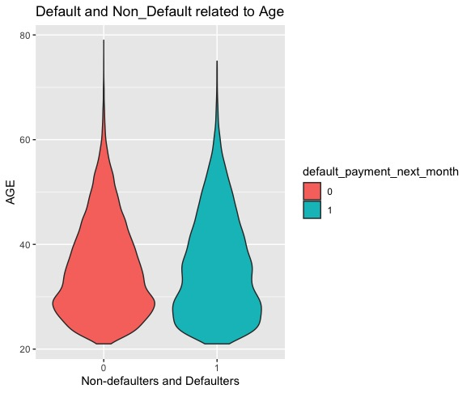

* 1. **Dataset Preprocessing**
     1. **Loading/Extraction of the source Dataset**

library(readxl)

myData <- read_excel("~/Desktop/default of credit card clients.xls")

myData

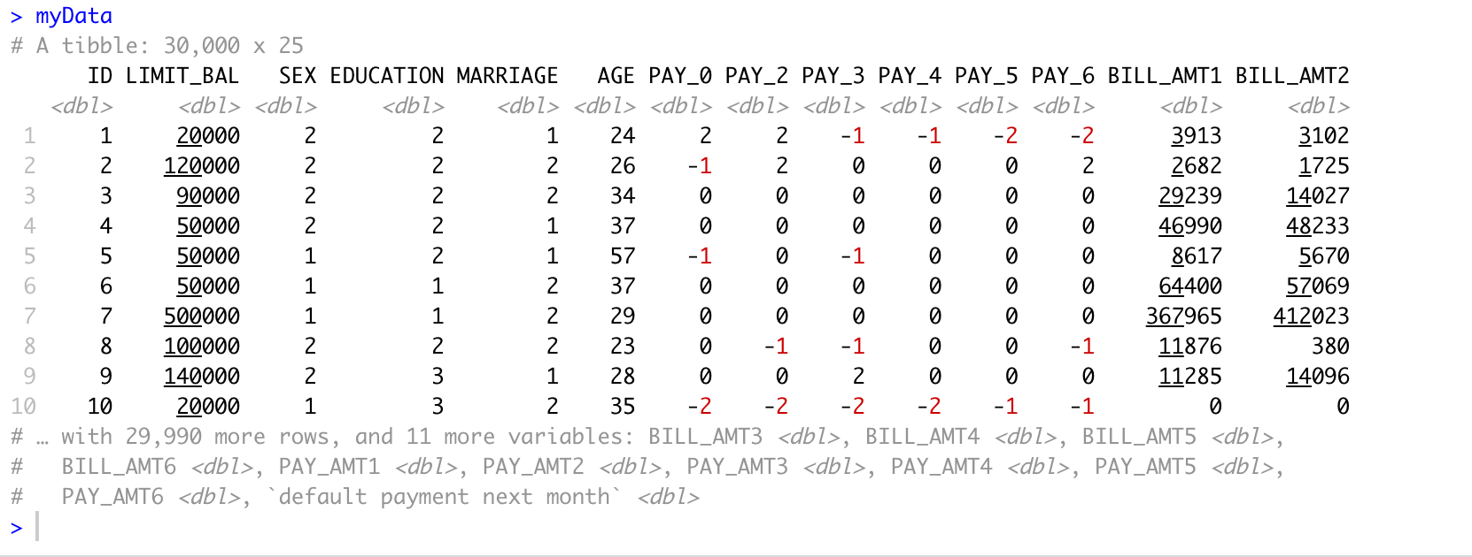

* + 1. **Extract/Filter Desired Attributes/Fields**

Desired attributes are following:

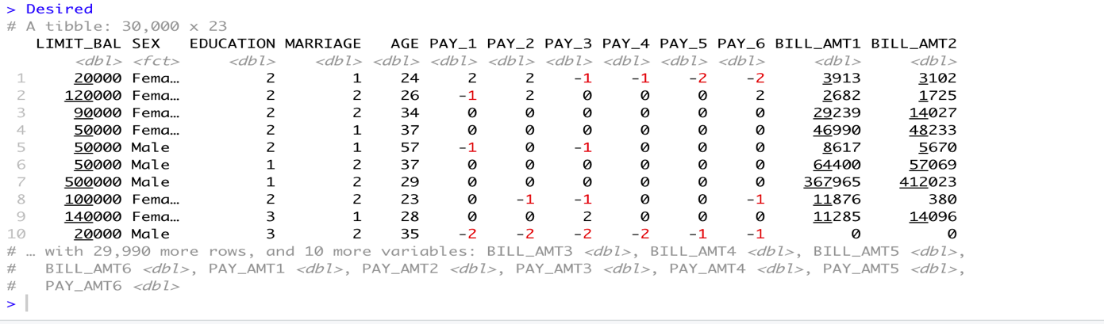

* + 1. **Removing Duplicates Records**

Checking duplicate records in our dataset:

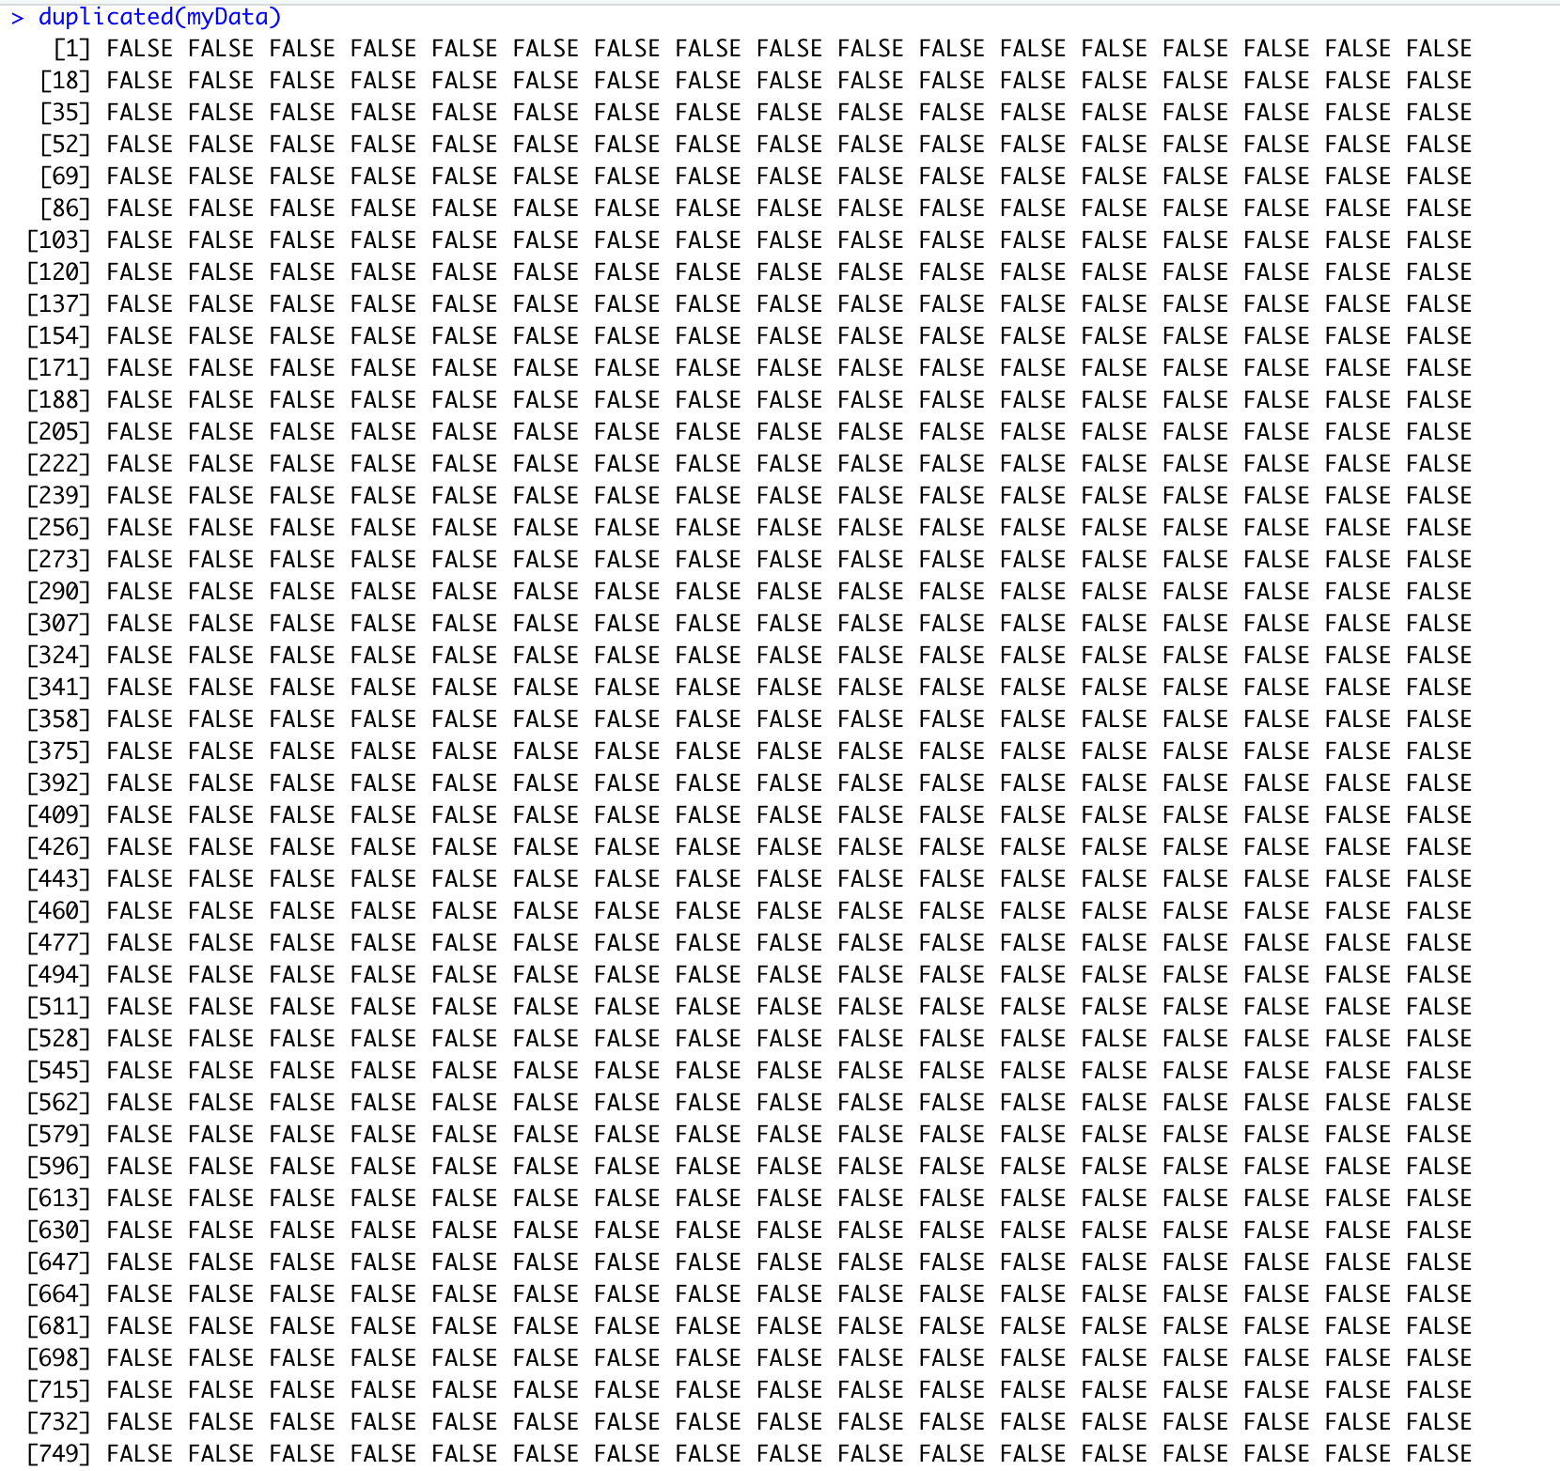

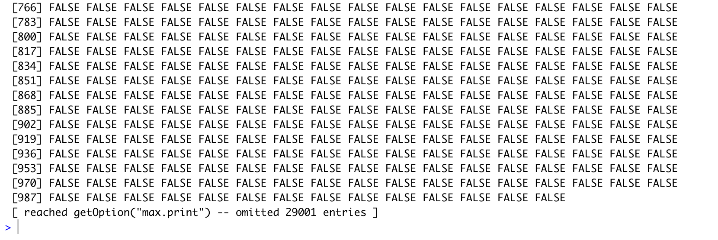

checkingDuplicate <- duplicated(myData)

length(checkingDuplicate[checkingDuplicate== TRUE])



So, we found out that there are no duplicate records in our dataset.

* + 1. **Structuring Date and Time Transformation**

There are not any dates and times in our dataset. So, we cannot structure date and time transformation.

* + 1. **Replacing NA for Date-Time Observation/Records**

There are not any dates and times in our dataset. So, there will be no NA in date-time.

* + 1. **Reformatting and Imputation of Date-Time Attributes**

There are not any dates and times in our dataset. So, we cannot impute and reformat Date-Time attributes.

* + 1. **Imputation on Data-Time column**

There are not any dates and times in our dataset. So, we cannot do imputation on Date-Time column.

* + 1. **Creation Classifiers**
* **Random Forest Classifier:**

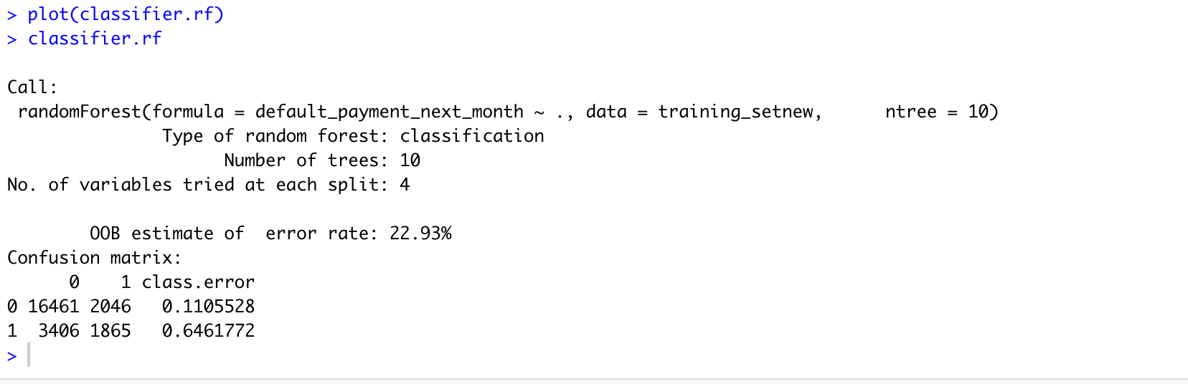

Predictions Done by Random Forest:

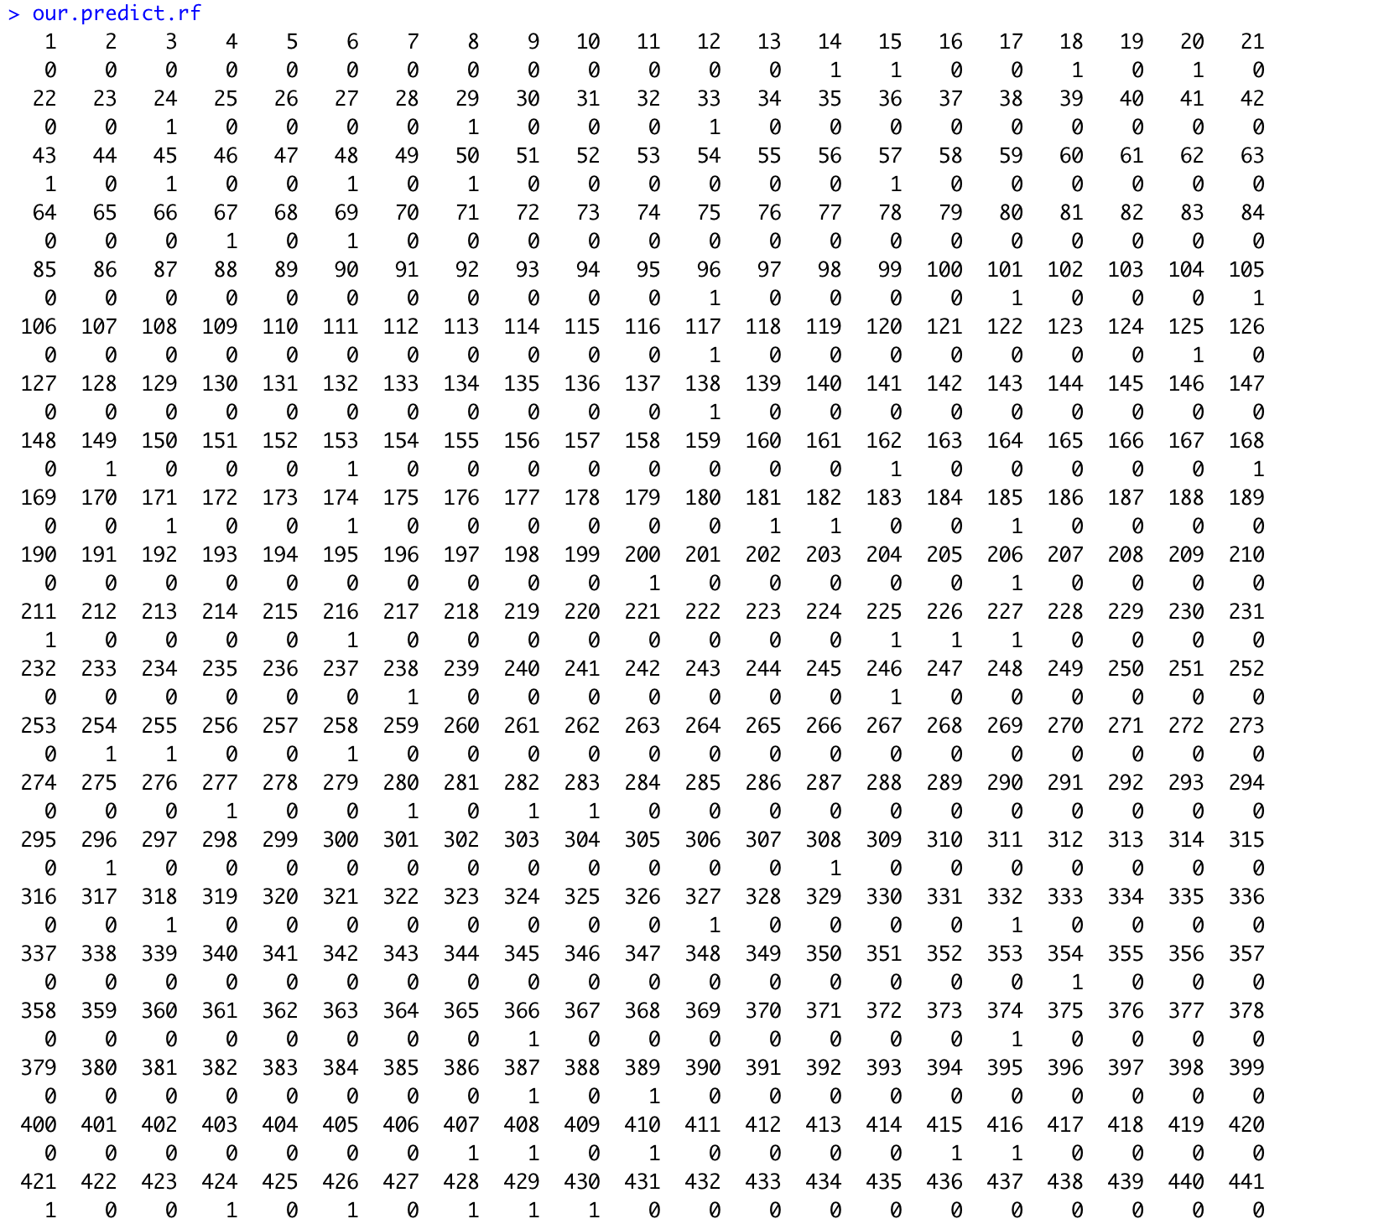

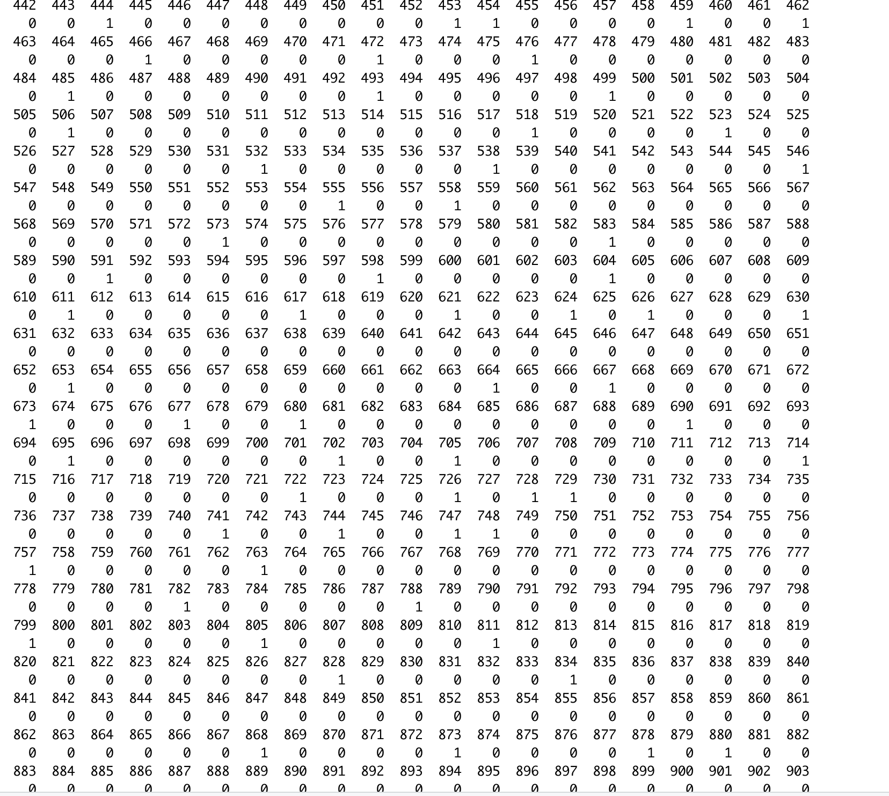

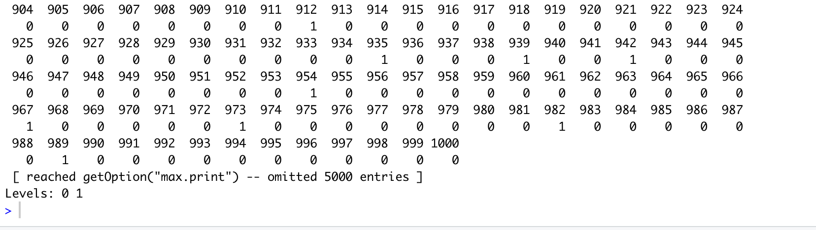

Confusion Matrix of Random Forest:

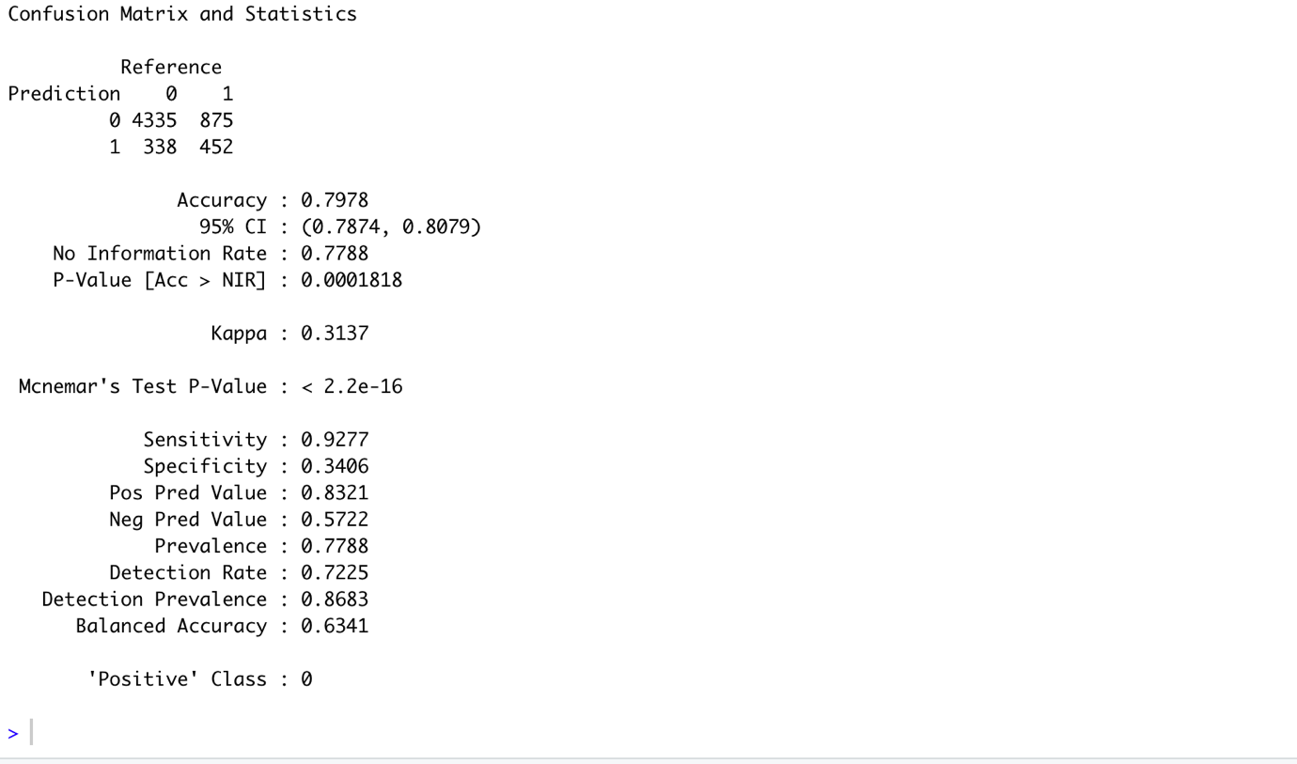

* **SVM Classifier:**

Splitting of Dataset for Training and Testing:

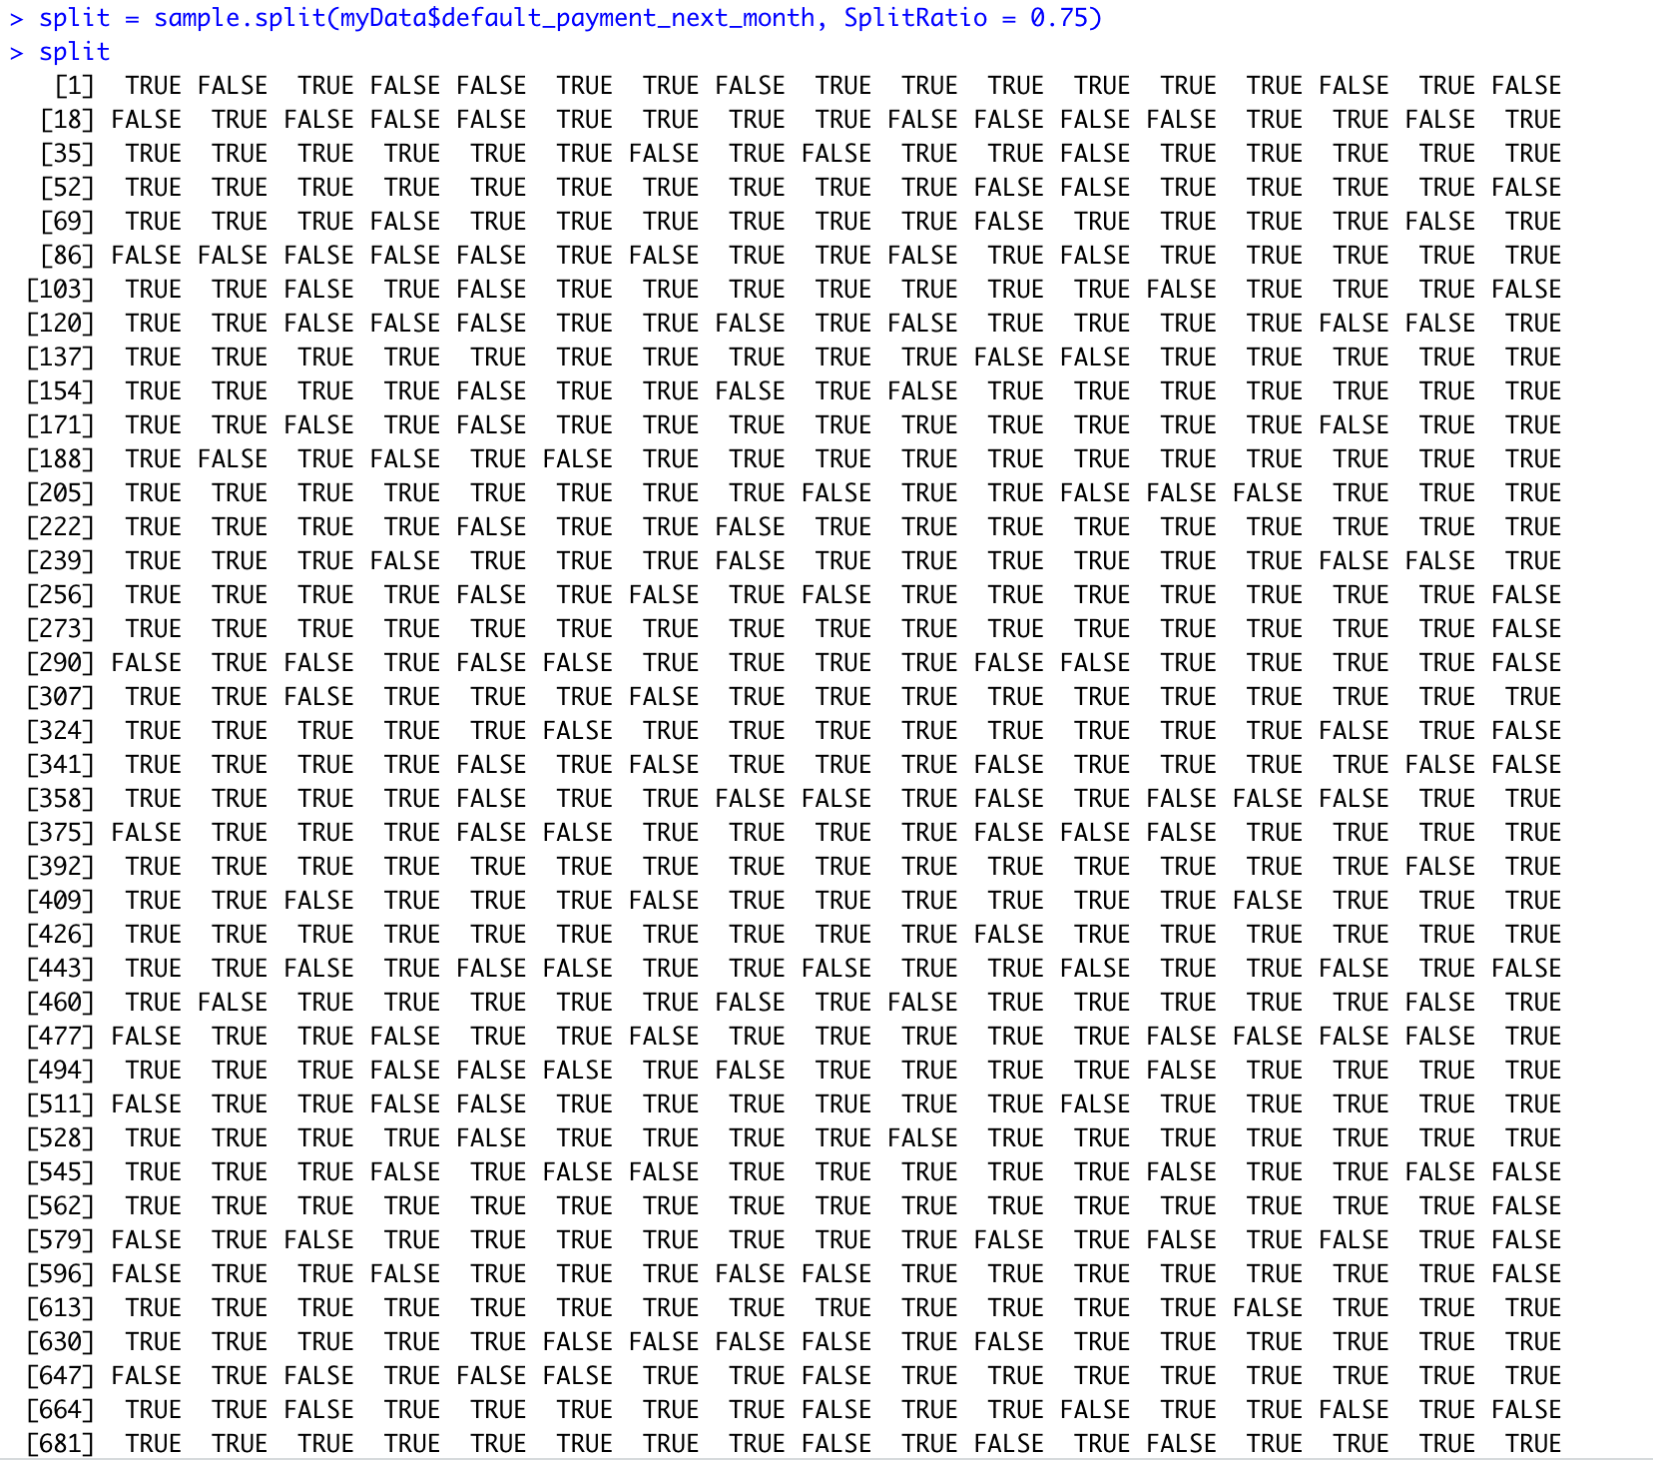

SVM Model:

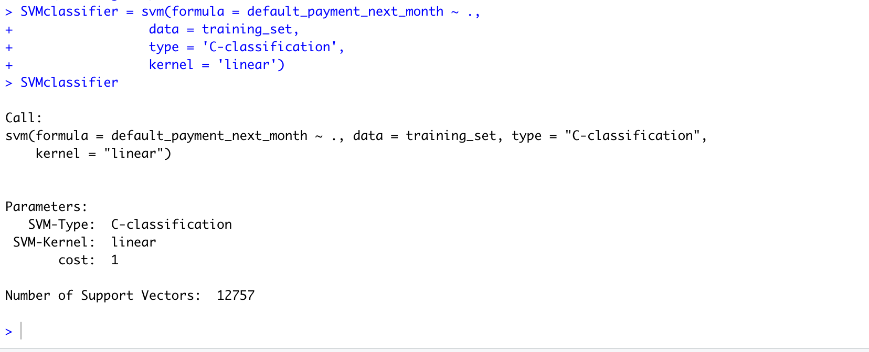

Prediction Done by SVM Model:

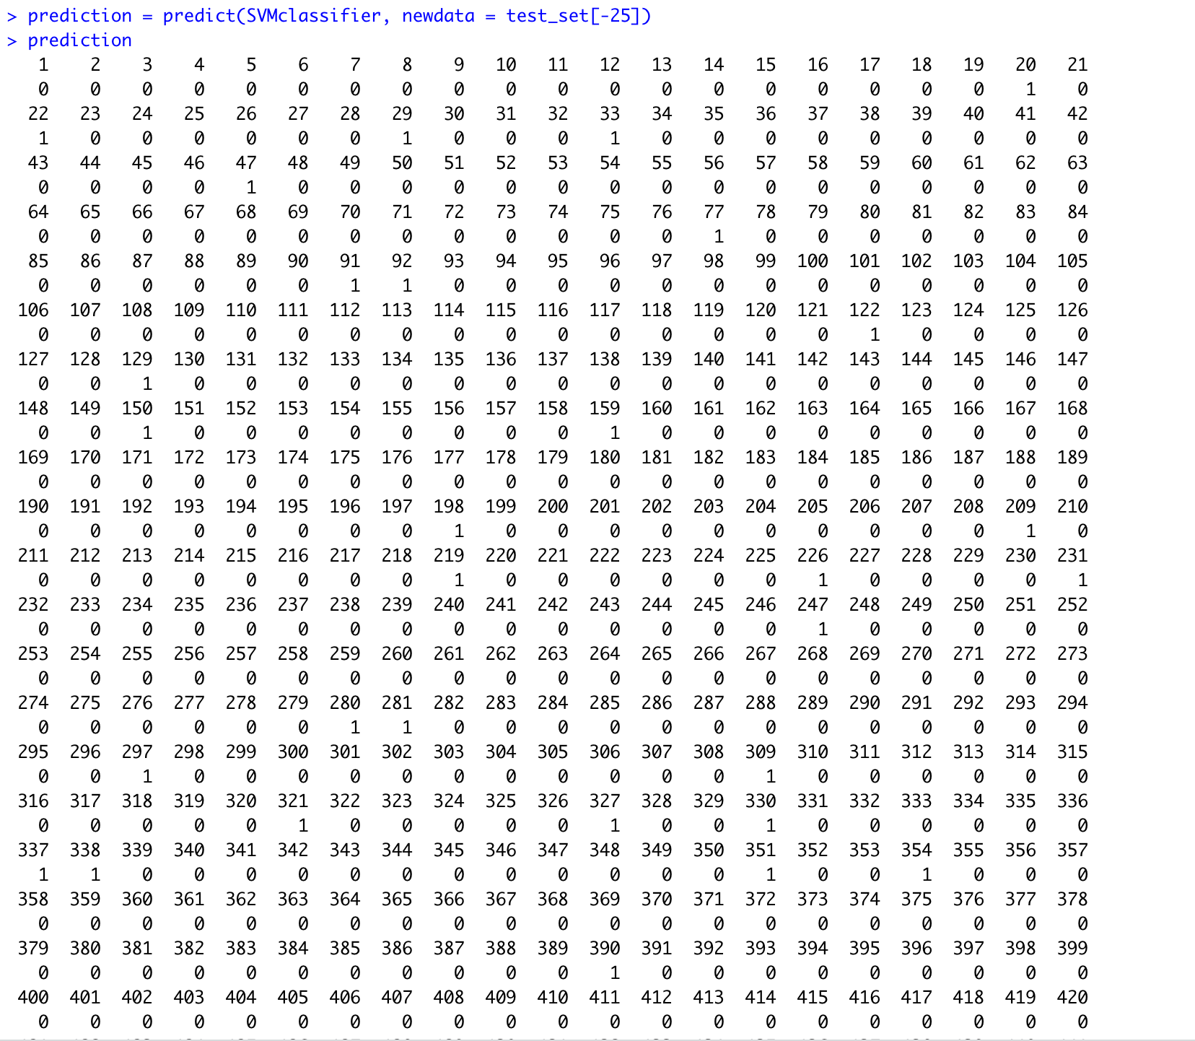

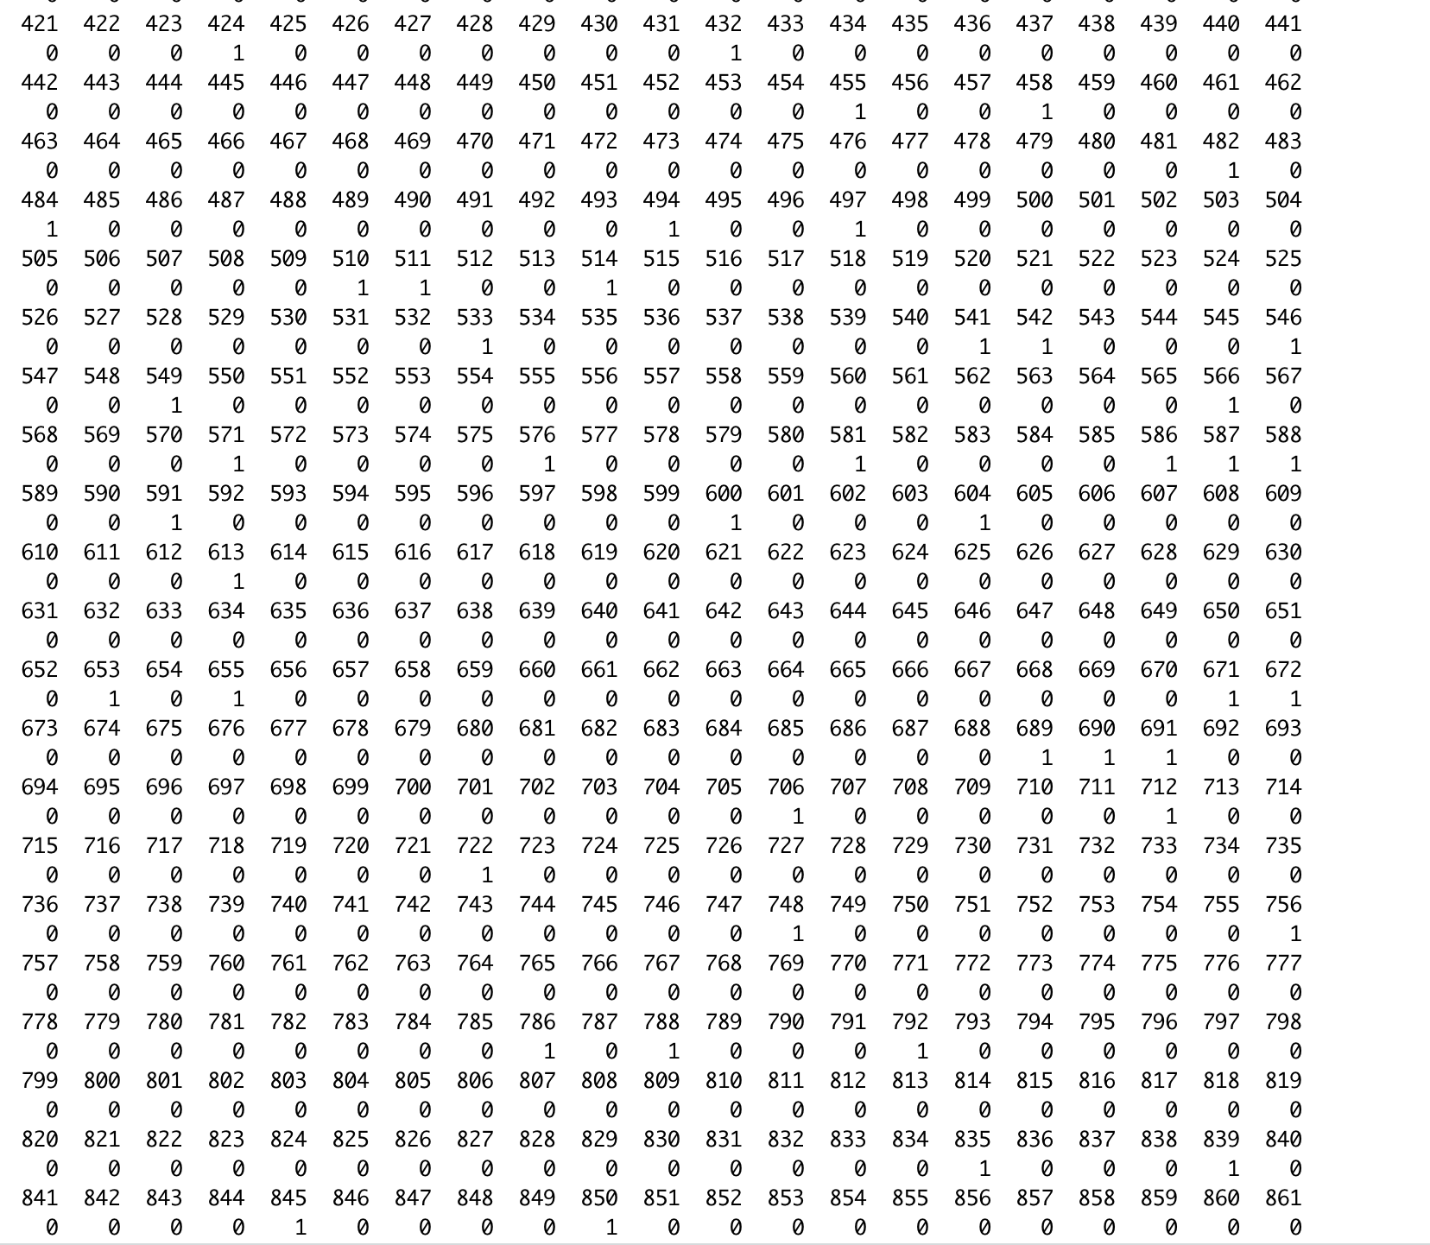

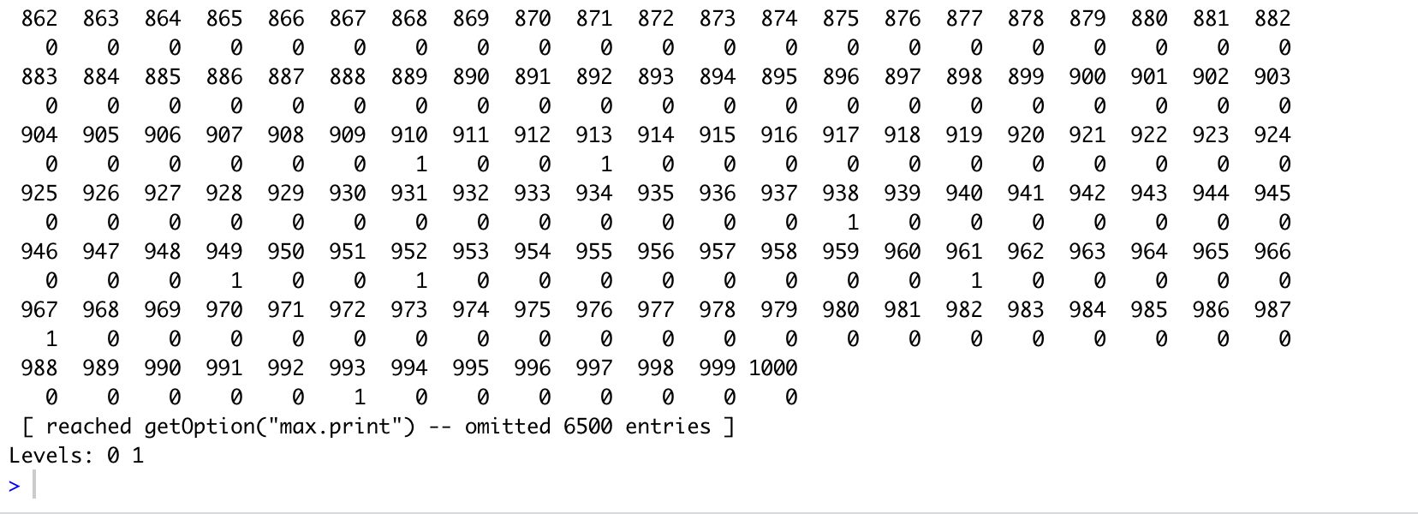

SVM confusion Matrix:

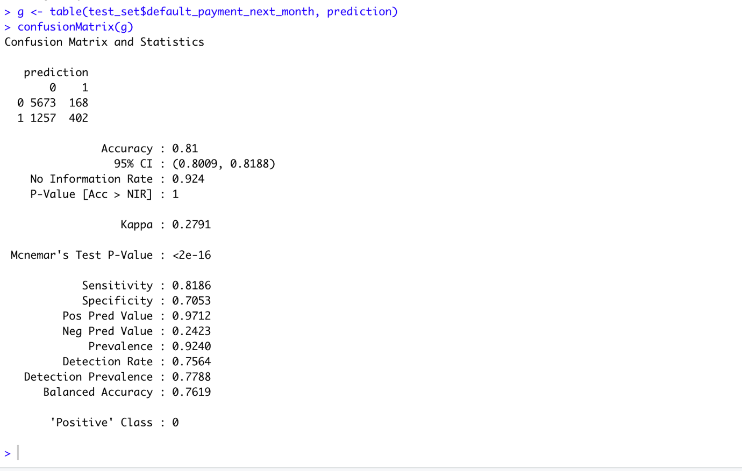

* **Neural Network Classifier:**

Neural Network Diagram:

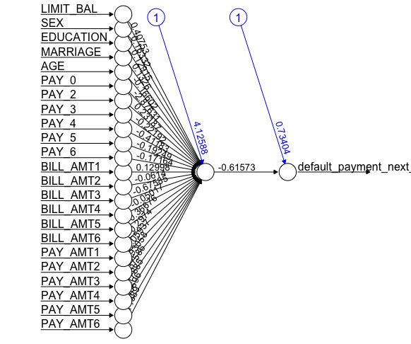

Confusion Matrix of Neural Network:

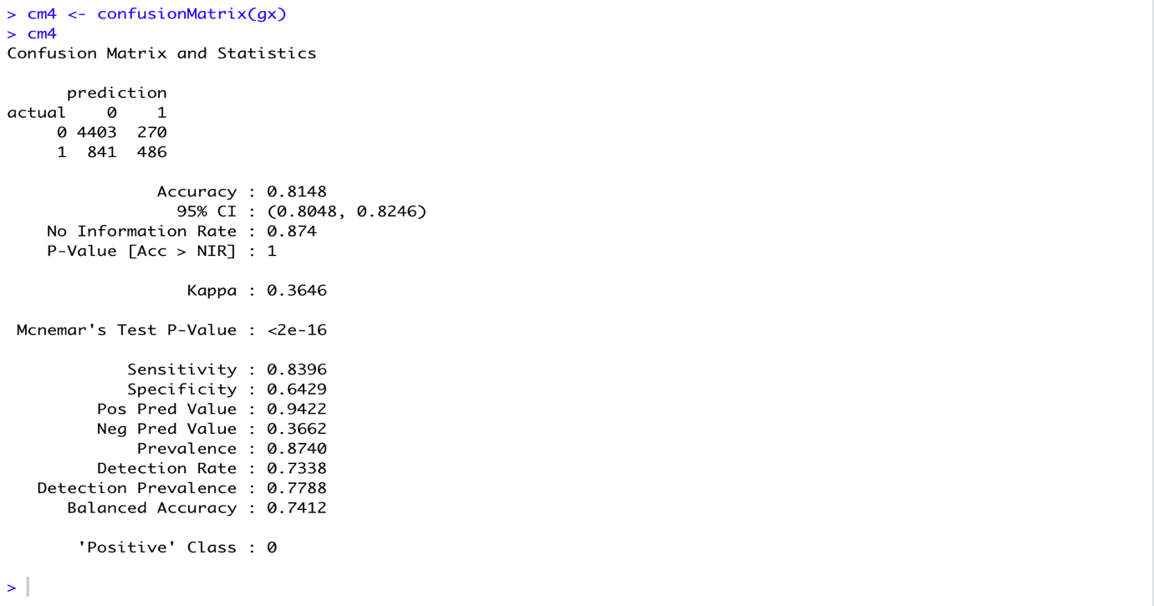

* + 1. **Removing Others NA Records of Dataset**

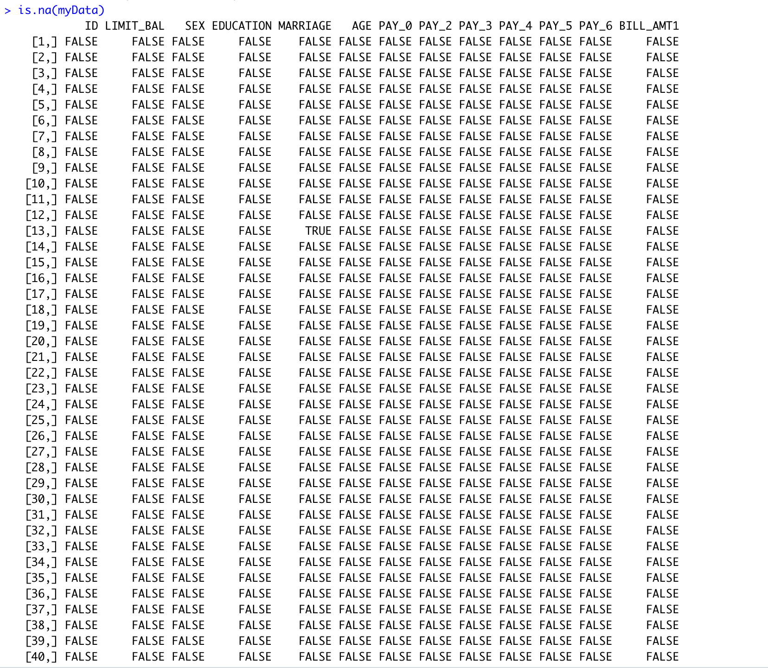

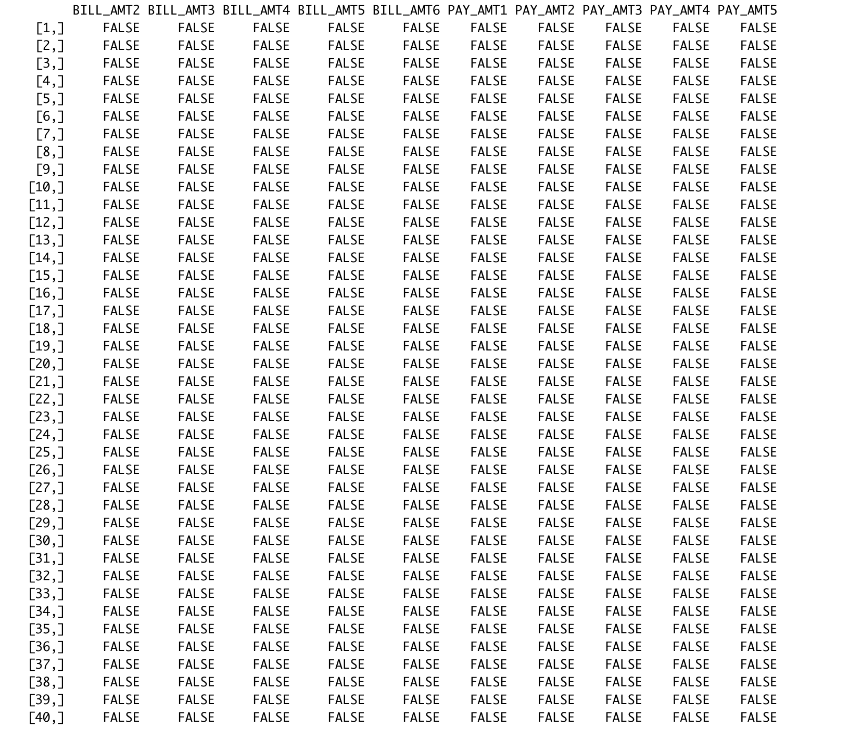

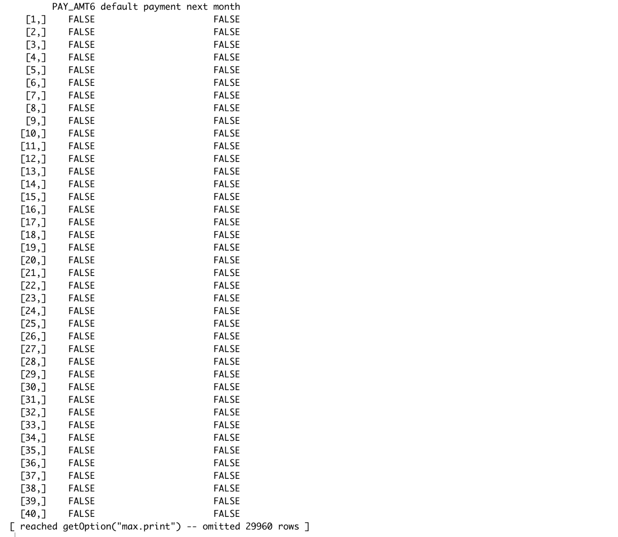

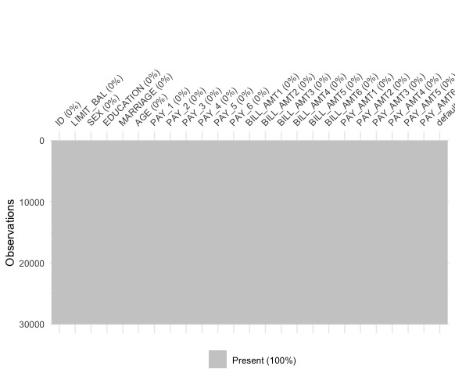

So, there are no NA records in our dataset.

1. **Identified Questions**

1: What are the factors that affect the most towards the default of payment next month?

2: Will I face default of payment next month? (can be answered by predicting)

3: What are the chances of not having default of payment next month?

1. **Machine Learning Modeling**
   1. **Statistics and Regression Modeling**
      1. **Correlation**

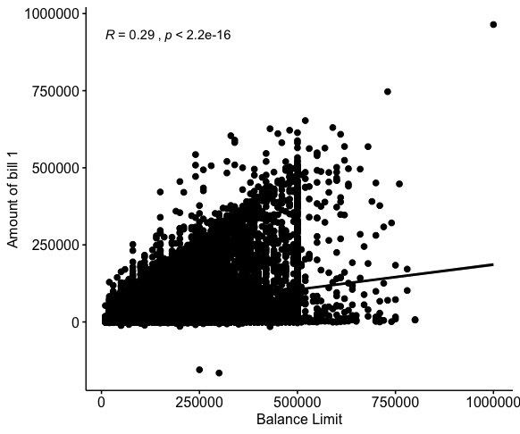

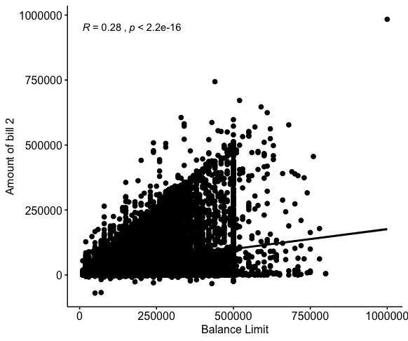

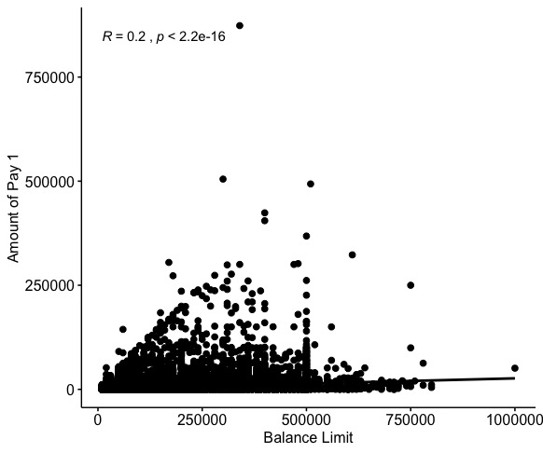

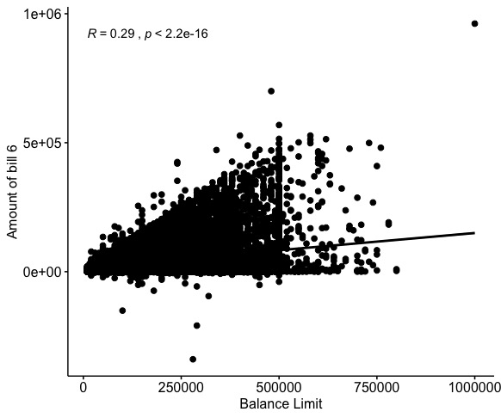

* 1. **Classification Modeling**
     1. **Decision Tree**

Predictions Done by Decision Tree:

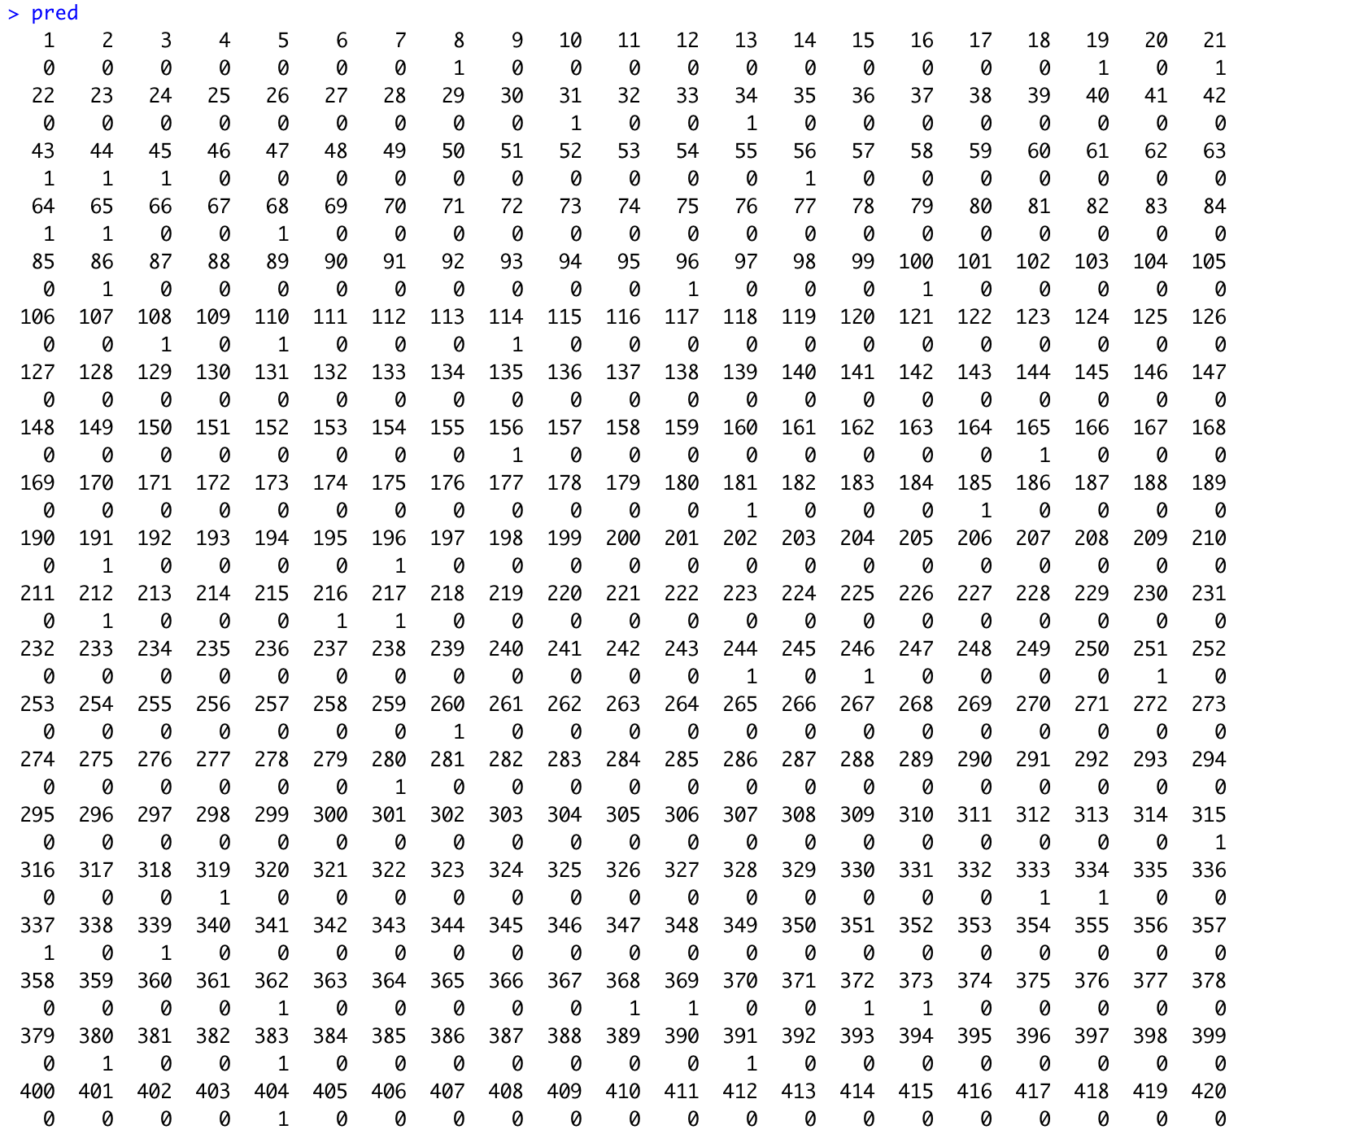

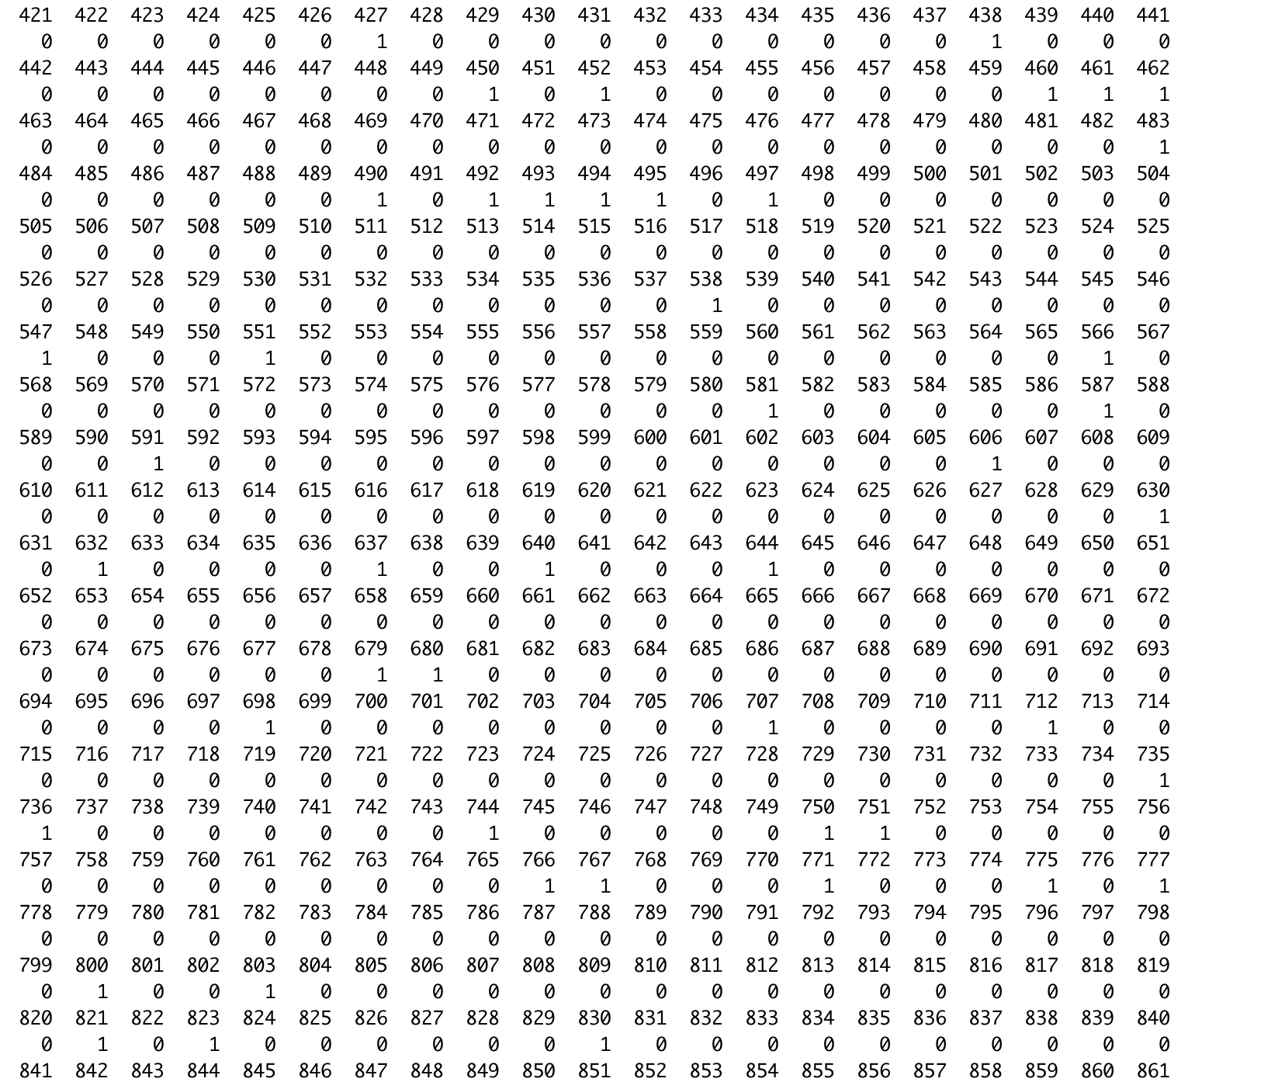

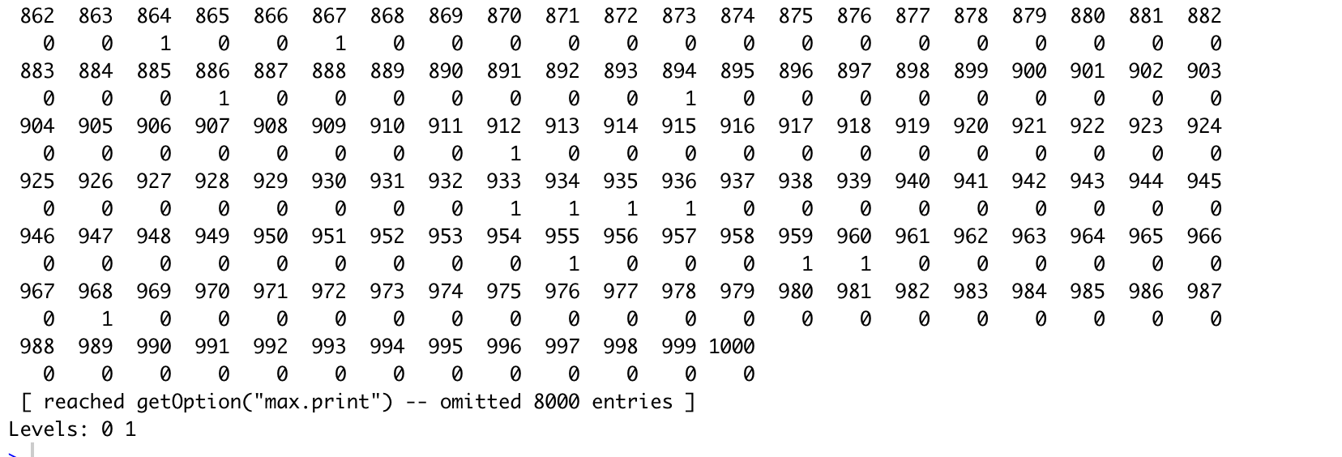

Description of Tree:

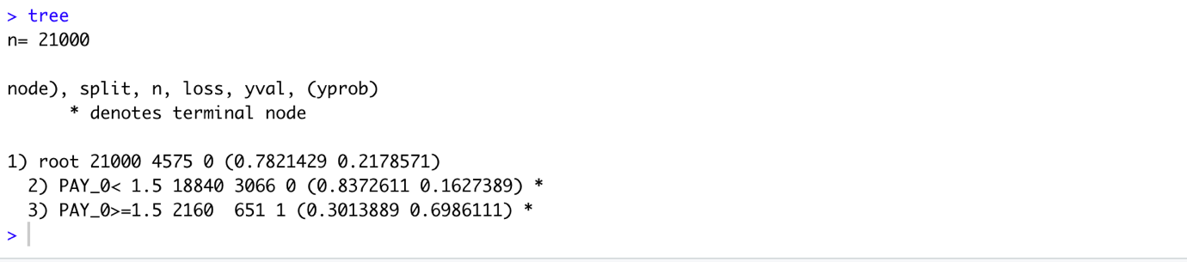

Tree Diagram:

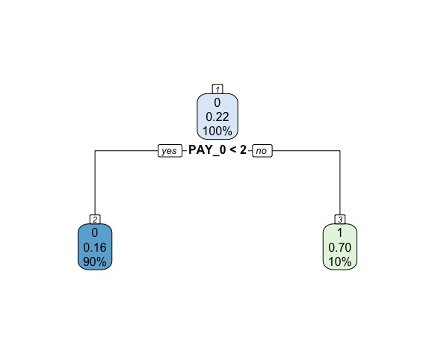

Confusion Matrix of Tree Model:

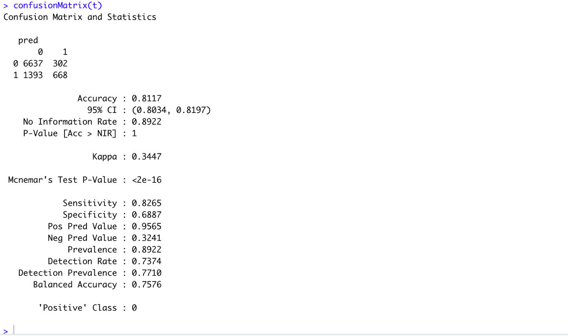

* + 1. **Naïve Bayes**

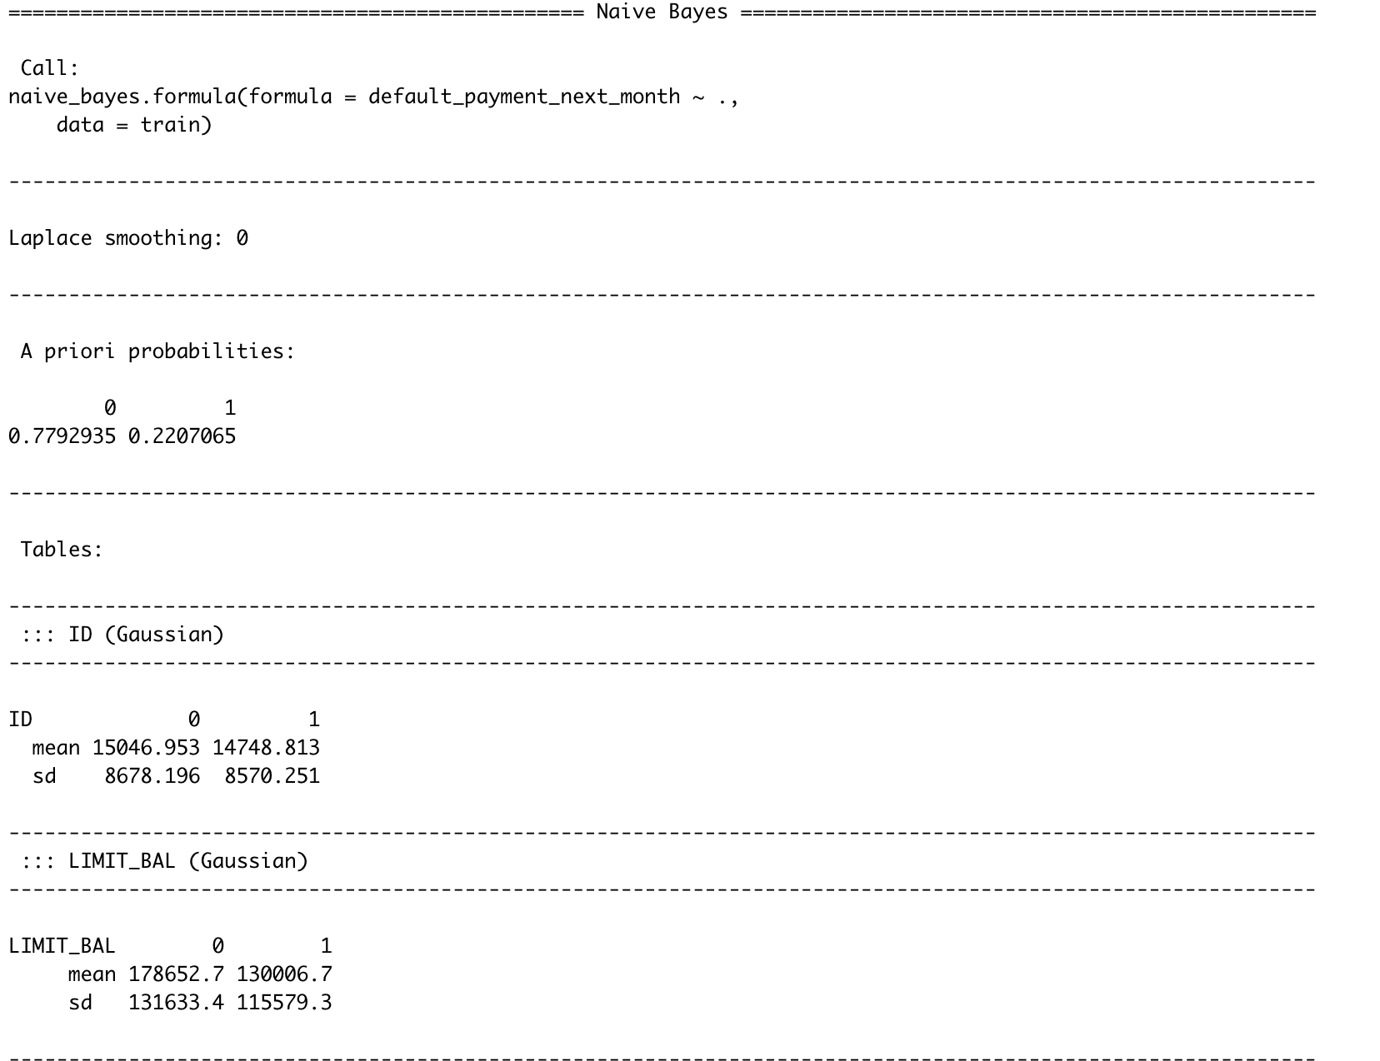

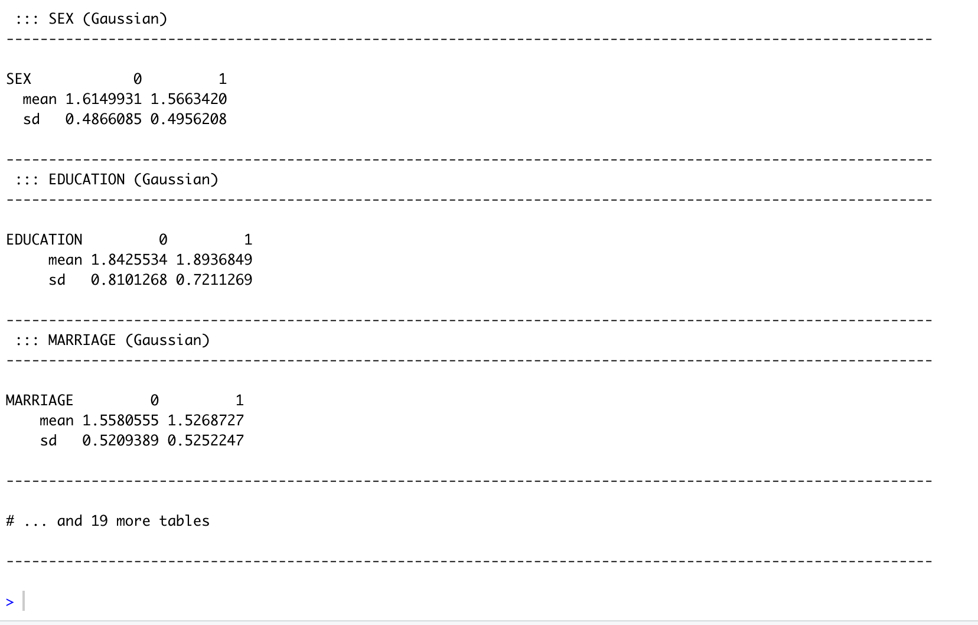

**Plotting of Naïve Bayes Model:**

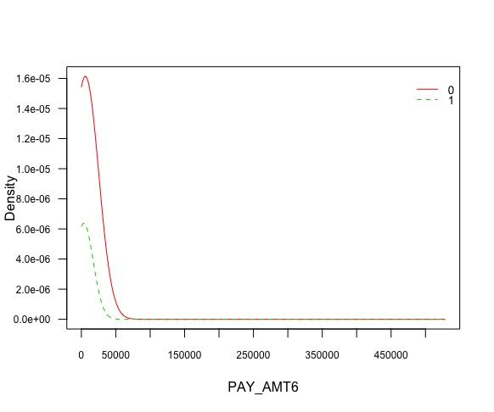

Confusion Matrix of Naïve Bayes Algorithm:

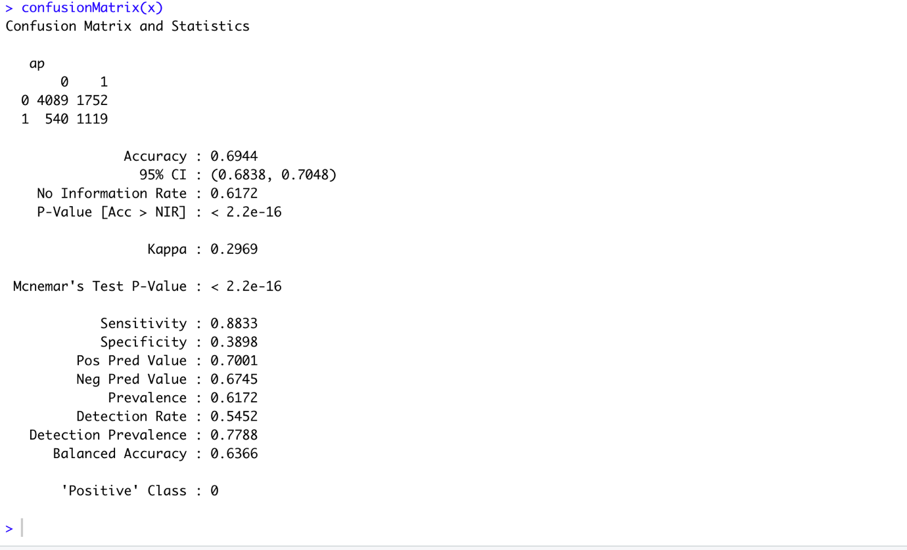

* + 1. **Comparison of Accuracy**

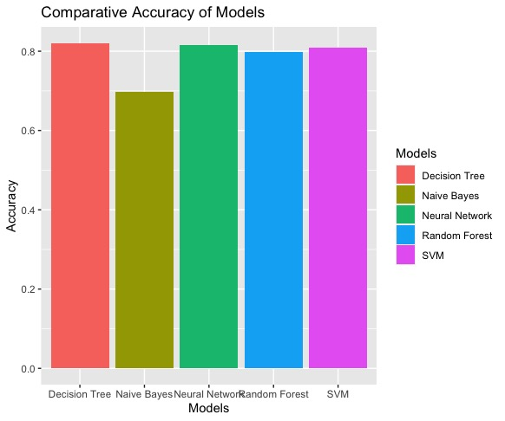

1. **Members Roles and Responsibilities**
   1. **Group Rules**

* Every group member has to listen to the group leader.
* Tasks will be divided by the group leader to all members and it will be mandatory for all to complete the assigned tasks.
* There will be a meeting regarding the project twice a week and it will be compulsory to attend the meeting.
* All group members will check and understand the work done by other members of the group.
* If any of group member is unable to do the assigned task then he should let the group leader know about it before the deadline.
* Regular update regarding the progress of project is compulsory for everyone.
* All must be punctual for the meeting.
  1. **Task List**

**No. Activities**

**N1** Finding Dataset

**N2** Understanding/Exploring Dataset

**N3** Learning and applying cleaning process on Dataset

**N4** Task Distribution

**N5** Designing the application for Dataset

**N6** Finding/Designing best Machine Learning Algorithm for the application

**N7** Implementing Machine Learning Algorithms on Application

**N8** Turning project to shiny application

**N9** System Testing

**N10** Final Touchups

**N11** Preparing for Project Presentation

* 1. **Matrix Score Weighted**

|  |  |  |  |  |  |
| --- | --- | --- | --- | --- | --- |
| **Members** | **Report** | **Dataset Cleaning** | **Machine Learning Modelling** | **Data Analysis and Visualization** | **Shiny Application** |
| Mohsin Basti | 80% | 75% | 75% | 75% | Pending |
| Abdullah Shafique | 20% | 25% | 25% | 25% | Pending |
| Rehmat Ali Haider | 0% | 0% | 0% | 0% | Pending |

1. **Shiny Application Screen shots and published URL**

Shiny application we have made for our project is interactive. It consists of 5 tabs name as “DataExploration”, “Plots”, “Models”, “Models Accuracy Comparison”, and “Prediction”.

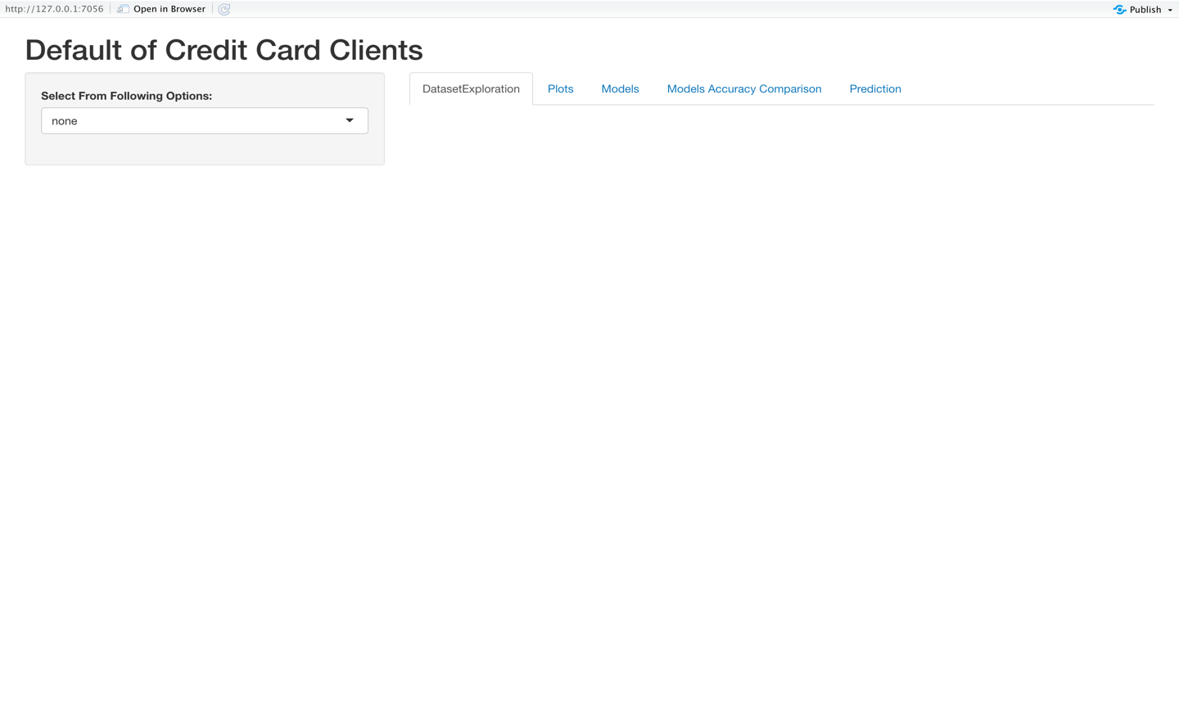

First tab “DataExploration” have a drop-down menu in the sidebar, drop-down menu has many options for data exploration. After selecting data exploration type from drop-down menu, the respective result will be displayed in the main panel.

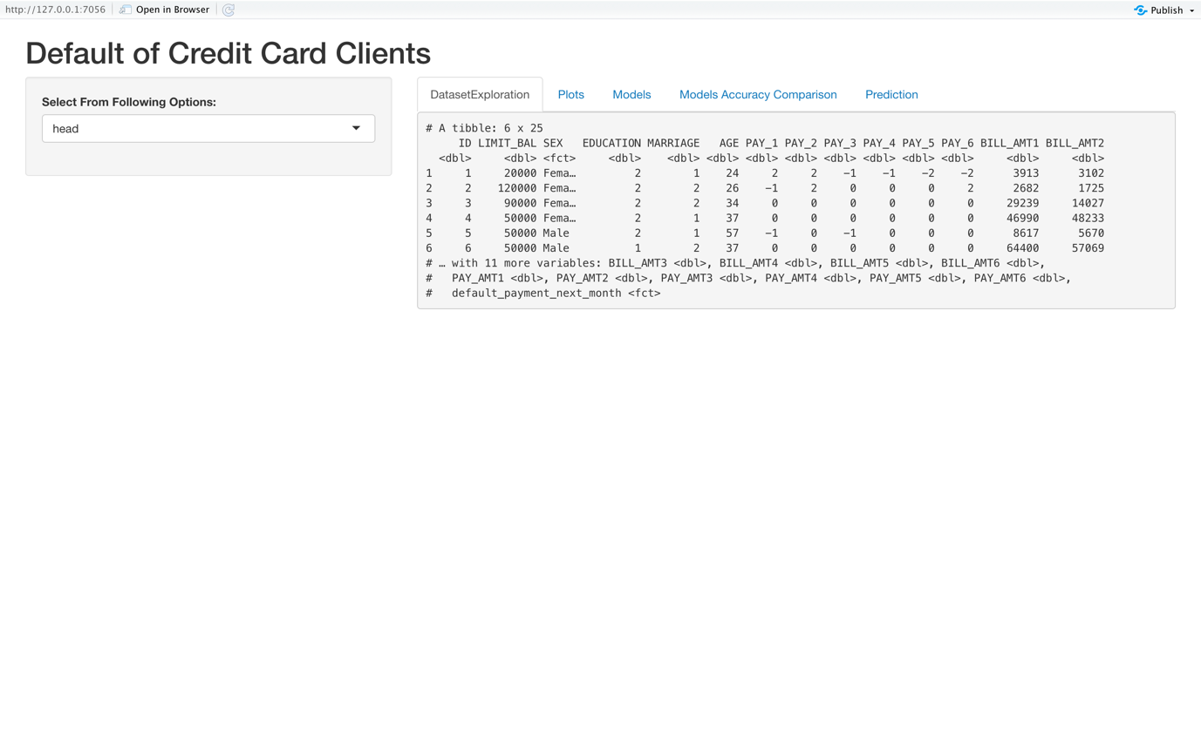

There comes “Plot” tab, which have a drop-down menu in the sidebar, drop-down menu has many options for different type of graphs. After selecting plot type from drop-down menu, the respective plot will be displayed in the main panel. Some graph types have further plot options for attributes.

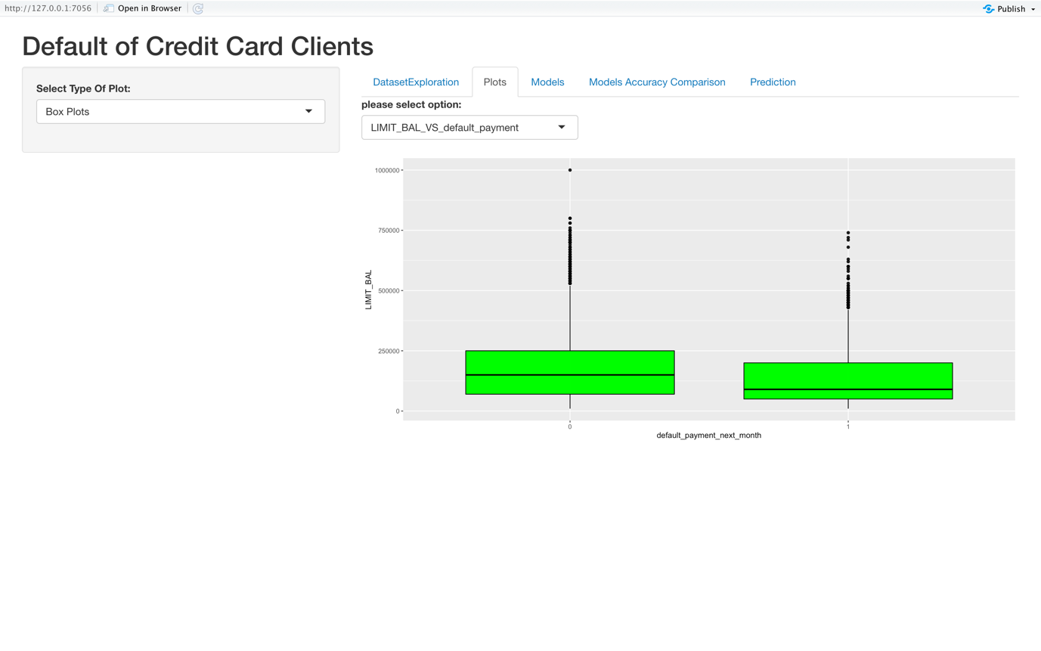

Then it comes “Models” tab, which have a drop-down menu in the sidebar, drop-down menu has many options for different type of models. After selecting model type from drop-down menu, the respective accuracy detail of model will be displayed in the main panel.

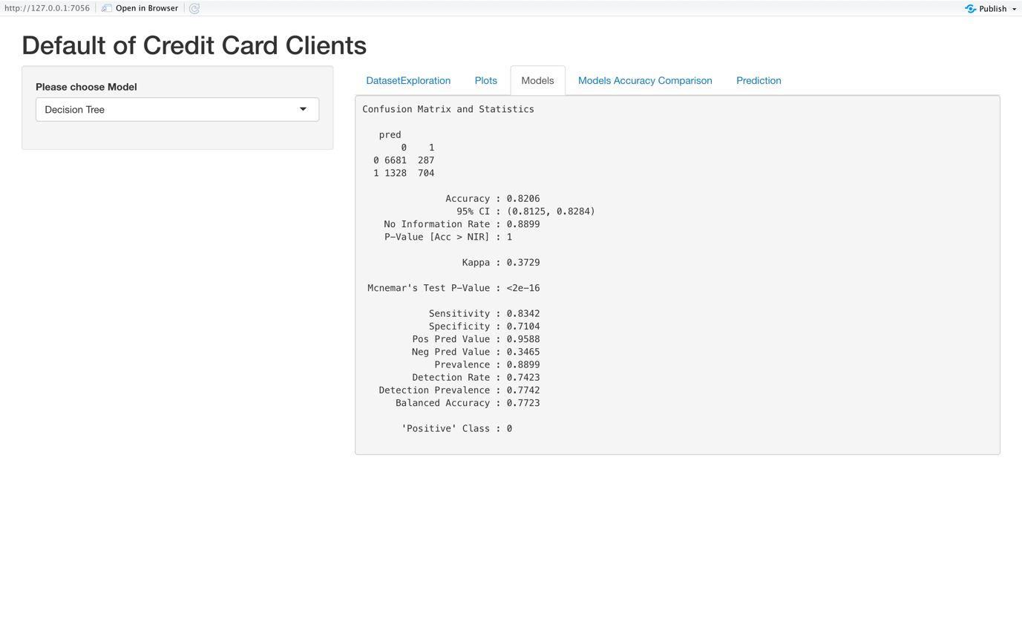

There comes “Models Accuracy Comparison” tab, which will display the accuracy comparison graph of all models trained in our project.

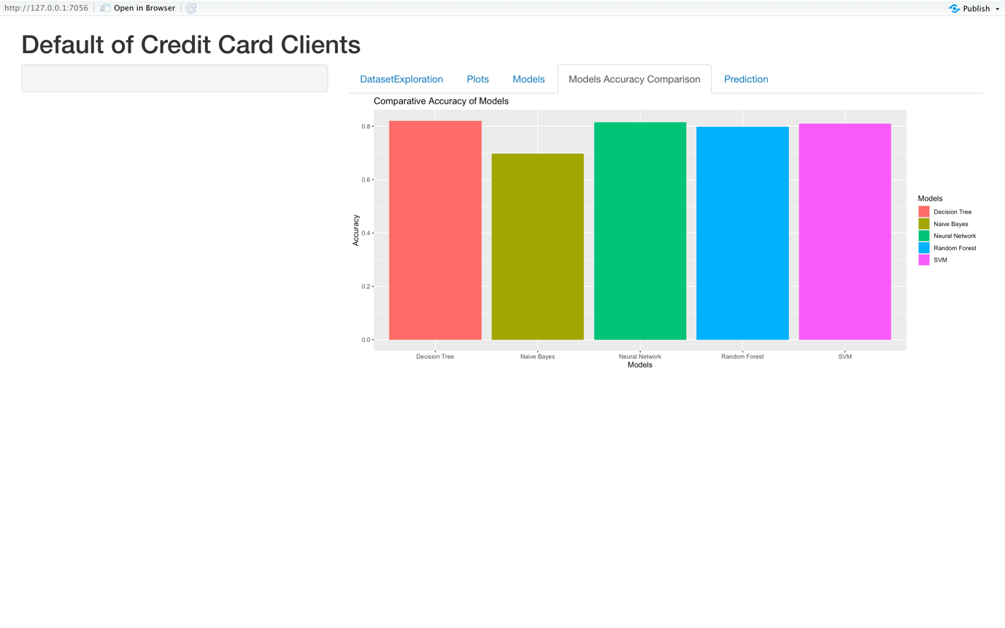

There comes the “Prediction” tab, in which we will adjust different inputs according to our requirements. Then according to selected inputs, the prediction will be done and after clicking on show output button, the prediction result will be displayed in the main panel.

